CWTS
China Wireless Telecommunication Standard (CWTS);
Working Group 1 (WG1);
UE Functions and Interlayer Procedures
in Connected Mode
TS C003 V3.0.0 (1999-10)
Technical Specification

Contents

1. Scope 5
2. References 5
3. Symbols and Abbreviations 5
3.1 Symbols 5
3.2 Abbreviations 6
4. General Description of Connected Mode 9
5. Description of UE states and state transitions 10
5.1 UE RRC States and State Transitions including GSM (PSTN / ISDN only) 10
5.2 UE RRC States and State Transitions including GSM / GPRS (IP only) 11
5.3 Transition from Idle Mode to Connecting State 12
5.4 Connecting State 12
5.4.1 Transition to Connected Mode 12
5.4.2 Transition to Idle Mode 12
5.5 Connected Mode States and Transitions 13
5.5.1 Cell Connected State 13
5.5.1.1 Control only substate 13
5.5.1.1.1 Transition from Control only substate to User data active substate 14
5.5.1.1.2 Transition from Control only substate to PCH 14
5.5.1.1.3 Transition from Control only substate to RRA connected state 14
5.5.1.1.4 Transition from Control only substate to Idle mode 14
5.5.1.2 User data active substate 14
5.5.1.2.1Transition from User data active substate to control only substate 14
5.5.1.2.2Transition from User data active substate to RACH + (USCH) / FACH or RACH + (USCH) / DSCH 15
5.5.1.2.3Transition from User data active substate to PCH 15
5.5.1.2.4Transition from User data active substate to RRA connected state 15
5.5.1.2.5Transition from User data active substate to Idle mode 15
5.5.1.2.6Transition between substates 15
5.5.1.2.6.1Transition from DCH/DCH to DCH/DCH+DSCH substate 15
Transition from DCH/DCH to DCH/DCH+DSCH substate occurs when DSCH is allocated.5.5.1.2.6.2Transition from DCH/DCH+DSCH to DCH/DCH substate 15
5.5.1.2.6.3Transition from DCH/DCH to DCH/DSCH+DSCH Ctrl substate 15
5.5.1.2.6.4Transition from DCH/DSCH+DSCH Ctrl to DCH/DCH substate 16
5.5.1.2.6.5Transition from DCH/DCH+DSCH to DCH/DSCH+DSCH Ctrl substate 16
5.5.1.2.6.6Transition from DCH/DSCH+DSCH Ctrl to DCH/DCH+DSCH substate 16
5.5.1.2.7Radio Resource Allocation tasks (Control only and User data active) 16
5.5.1.2.8RRC Connection mobility tasks (Control only and User data active) 17
5.5.1.2.8.1Localised Service Area (LSA) support 17
5.5.1.2.9 Transfer and update of system information ( Control only and User data active ) 17
.5.5.1.3RACH / FACH and RACH + USCH / FACH substates 17
5.5.1.3.1Transition from RACH/FACH to RACH+USCH/FACH substate 18
5.5.1.3.2Transition from RACH+USCH/FACH to RACH/FACH substate 18
5.5.1.3.3Transition from RACH/FACH to User data active substates 18
5.5.1.3.4Transition from RACH+USCH/FACH to User data active substates 18
5.5.1.3.5Transition from RACH/FACH or RACH+USCH/FACH to PCH substate 18
5.5.1.3.6Transition from RACH/FACH or RACH+USCH/FACH to Idle Mode 18
5.5.1.3.7Transition from RACH/FACH or RACH+USCH/FACH to RACH / DSCH or RACH+USCH / DSCH state 18
5.5.1.3..8Transition from RACH/FACH or RACH+USCH/FACH to RRA Connected State 18
5.5.1.3.9Radio Resource Allocation Tasks (RACH/FACH) 19
5.5.1.3.10Radio Resource Allocation Tasks (RACH+USCH/FACH) 19
5.5.1.3.11RRC Connection mobility tasks (RACH + (USCH)/FACH) 19
5.5.1.3.12 Transfer and update of system information ( RACH+(USCH)/FACH ) 19
5.5.1.4RACH/DSCH and RACH+USCH/DSCH substates 20
5.5.1.5PCH substate 20
5.5.1.5.1Transition from PCH to RRA Connected State 20
5.5.1.5.2Transition from PCH to RACH/FACH substate 20
5.5.1.5.3Transition from PCH to RACH+USCH/FACH substate 21
5.5.1.5.4Transition from PCH to RACH/DSCH or RACH+USCH/DSCH substates 21
5.5.1.5.5Radio Resource Allocation Tasks (PCH) 21
5.5.1.5.6RRC Connection mobility tasks (PCH) 21
5.5.1.5.7 Transfer and update of system information ( PCH ) 21
5.5.2 RRA Connected State 21
5.5.2.1 Transition from RRA Connected State to Cell Connected State 22
5.5.2.2 Radio Resource Allocation Tasks (RRA Connected) 22
5.5.2.3 RRC Connection mobility tasks (RRA Connected) 22
5.5.2.4 Transfer and update of system information ( RRA connected ) 22
5.6 Inter-system handover with simultaneous IP and PSTN/ISDN domain services 22
5.6.1 Inter-system handover TD-SCDMA RAN to GSM / BSS 22
5.6.2 Inter-system handover GSM / BSS to TD-SCDMA RAN 23
6. Radio Bearer Control – Overview of Procedures 24
6.1 Configurable parameters 24
6.2 Typical configuration cases 24
6.3 RRC Elementary Procedures 25
6.3.1 Category 1: Radio Bearer Configuration 25
6.3.2 Category 2: Transport Channel Configuration 25
6.3.3 Category 3: Physical Channel Configuration 26
6.3.4 Category 4: Transport Format Combination Restriction 26
6.3.5 Category 5: Uplink Dedicated Channel Control in CRNC 26
7. Examples of procedures 27
7.1 RRC Connection Establishment and Release Procedures 27
7.1.1 RRC connection establishment 27
7.1.2 UE Initiated Signalling Connection Establishment 29
7.1.3 Normal RRC Connection Release 30
7.1.3.1 RRC Connection Release from Dedicated Physical Channel 31
7.1.3.2 RRC Connection Release without Dedicated Physical Channel 33
7.2 Radio Bearer Procedures 35
7.2.1 Radio Bearer Configuration 35
7.2.1.1 Radio Bearer Establishment 35
7.2.1.1.1 Radio Bearer Establishment with Dedicated Physical Channel Activation 36
7.2.1.1.2 Radio bearer Establishment with Unsynchronised Dedicated Physical Channel Modification 38
7.2.1.1.3 Radio bearer Establishment with Synchronised Dedicated Physical Channel Modification 40
7.2.1.1.4 Radio Bearer Establishment without Dedicated Physical Channel 42
7.2.1.1.5 Radio Bearer Establishment with USCH Channel Allocation 44
7.2.1.2 Radio Bearer Release 45
7.2.1.2.1 Radio Bearer Release with Unsynchronised Dedicated Physical Channel Modification 45
7.2.1.3 Bearer Reconfiguration 47
7.2.1.3.1 Unsynchronised Radio Bearer And Signalling Link ReconfiguraAtion 47
7.2.2 Transport Channel Reconfiguration 49
7.2.2.1 Unsynchronised Transport Format Set Reconfiguration 49
7.2.2.2 Asymmetric transport channel reconfiguration 50
7.2.3 Physical Channel Reconfiguration 51
7.2.3.1 UE-Originated DCH Activation 52
7.2.3.2 UE-terminated synchronised DCH Modify 54
7.2.3.3 UE-terminated DCH Release 55
7.2.3.4 UE-Originated Rapid DCH Initialization 57
7.2.4 Transport Format Combination Control 59
7.2.4.1 Transport Format Combination Limitation 59
7.2.5 Dynamic Resource Allocation Control of Uplink DCH:s 60
7.3 Data transmission 62
7.3.1 Acknowledged-mode data transmission in DCH / DCH + DSCH 62
7.3.2 Acknowledged-mode data transmission in USCH/FACH 64
7.3.3 Data transfer on USCH/DSCH 66
7.4 RRC Connection mobility procedures 68
7.4.1 Handover Measurement Reporting 69
7.4.2 Cell Update 70
7.4.3 RRA Update 72
7.4.4 Radio Link Addition 74
7.4.5 Radio Link Removal 74
7.4.6 Combined radio link addition and removal 75
7.4.7 Hard Handover 77
7.4.8 RRC Connection re-establishment 79
7.4.9 Inter-system Handover: GSM/BSS to TD-SCDMA RAN 82
7.4.10 Inter-System Handover: TD-SCDMA RAN to GSM/BSS, PSTN/ISDN domain services 84
7.4.11 Baton handover 86
7.5 CN originated paging request in connected mode 87
7.5.1 RAN coordinated paging using DCCH 87
7.5.2 RAN coordinated paging using PCCH 88
7.5.3 UE coordinated paging 88
7.6 RAN originated paging request and paging response 88
7.7 Other procedures 90
7.7.1 UE Capability Information 90
7.7.2 Random access transmission sequence 91
8. Traffic volume monitoring 93
Annex A (informative): RRC Connection Establishment - Case C 94
History 95

Scope
This document defines the UE States and the principal tasks undertaken by the UE when in Connected Mode. It includes informative interlayer procedures for the UE to perform the required tasks.
This document attempts to provide a comprehensive overview of the different states and transitions within the connected mode of a CWTS terminal. The applicable set of states for a given service may be a subset of the total set of possible states.
In addition to describing the states and related transitions, this document describes all procedures that assign, reconfigure and release radio resources. Included are e.g. procedures for transitions between different states and substates, handovers and measurement reports. The emphasis is on showing the combined usage of both peer-to-peer messages and interlayer primitives to illustrate the functional split between the layers, as well as the combination of elementary procedures for selected examples. The peer-to-peer elementary procedure descriptions are described in the related protocol descriptions[1], [2], [3] and they are thus not within the scope of this document.

References
[1] 3GPP TS25.321, “MAC Protocol Specification”
[2] 3GPP TS 25.322, “RLC Protocol Specification”
[3]
[4] 3GPP TS 25.304, “UE Procedures in Idle Mode”
[5]
- CWTS TSC102 “Physical channels and mapping of transport channels and physical channels”
- CWTS TSC001 “Radio Interface Protocol Architecture”
- CWTS TSC203 “RRC Protocol Specification”

Symbols and Abbreviations

Symbols
For the purposes of the present document, the following symbols apply:
+ A “+” in a substate name means that transport channels separated by the symbol can both be used in that substate. The name doesn’t define whether simultaneous multicode transmission is allowed on these channels. E.g. in DCH / DCH + DSCH both downlink transport channels can be actively transmitting at the same time, but in RACH + USCH / FACH simultaneous transmission on RACH and USCH requiring multicode/multi-timeslot transmission should not be necessary.

Abbreviations

AS Access Stratum
BCH Broadcast Channel
BCCH Broadcast Control Channel
BSS Base station subsystem
CC Call control
CCH Control Channel
CN Core Network
CWTS China Wireless Telecommunication Standard
DC Dedicated Control
DCCH Dedicated Control Channel
DCH Dedicated Channel
DL Downlink
DPCCH Dedicated physical control channel
DPCH Dedicated physical channel
DRNC Drift Radio Network Controller
DSCH Downlink Shared Channel
DTCH Dedicated Traffic Channel
FACH Forward Link Access Channel
FDD Frequency Division Duplex
GPRS Genreal packet radio services
GSM Global system for mobile communicztion
HO Handover
IMSI International Mobile Subscriber Identity
IP Internet protocol
ITU International Telecommunication Union
L1 Layer 1 (physical layer)
L2 Layer 2 (data link layer)
L3 Layer 3 (network layer)
LAC Link Access Control
LAI Location Area Identity
LSA Localised service area
MAC Medium Access Control
MM Mobility Management
NAS Non Access Stratum
NW Network
PCCH Paging Control Channel
PCH Paging Channel
PDU Protocol Data Unit
PHY Physical layer
PhyCH Physical Channels
QoS Quality of Services
RAB Radio Access Bearer
RB Radio Bearer
RACH Random Access Channel
RLC Radio Link Control
RNC Radio Network Controller
RNS Radio Network Subsystem
RNTI Radio Network Temporary Identity
RRA RAN registration area
RRC Radio Resource Control
SAP Service Access Point
SCCH Synchronization Control Channel
SCH Synchronization Channel
SRNC Serving Radio Network Controller
SRNS Serving Radio Network Subsystem
TCH Traffic Channel
TDD Time Division Duplex
TFCI Transport Format Combination Indicator
TFCS Transport Format Combination Set
TFI Transport Format Indicator
TFS Transport format set
TMSI Temporary Mobile Subscriber Identity
TPC Transmit Power Control
UE User Equipment
UL Uplink
UMTS Universal Mobile Telecommunications System

USCH Uplink Shared Channel

General Description of Connected Mode
The connected mode is entered when the RRC connection is established. The UE is assigned a radio network temporary identity (RNTI) to be used as UE identity on common transport channels. Two types of RNTI exist. The Serving RNC allocates an s-RNTI for all UEs having an RRC connection. The combination of s-RNTI and an RNC-ID is unique within a PLMN. c-RNTI is allocated by each Controlling RNC through which UE is able to communicate on DCCH. c-RNTI is always allocated by RAN when a new UE context is created to an RNC, but the UE needs its c-RNTI only for communicating on common transport channels.
The UE leaves the connected mode and returns to idle mode when the RRC connection is released or at RRC connection failure.
Within connected mode the level of UE connection to RAN is determined by the quality of service requirements of the active Radio Bearers and the characteristics of the traffic on those bearers.
The UE-RAN interface is designed to support a large number of UEs using packet data services by providing flexible means to utilize statistical multiplexing. Due to limitations, such as air interface capacity, UE power consumption and network availability, the dedicated resources cannot be allocated to all of the packet service users at all times.
The UE state in the connected mode defines the level of activity associated to the UE. The key parameters of each state are the required activity and resources within the state and the required signalling prior to the data transmission. The state of the UE shall at least be dependent on the application requirement and the period of inactivity.
Uplink Shared Channel(USCH) uplink resources are available to UE’s with an access protocol similar to the RACH. The USCH resources support uplink packet communication for numerous UEs with a set of shared, contention-based USCH channels allocated to the cell.
The different levels of UE connection to RAN are listed below:
- No signalling connection exists
The UE is in idle mode and has no relation to RAN, only to CN. For data transfer, a signalling connection has to be established.
- Signalling connection exists
When at least one signalling connection exists, the UE is in connected mode and there is normally an RRC connection between UE and RAN. The UE position can be known on different levels:
- RAN Registration Area (RRA) level
The UE position is known on RRA level. The RRA is a set of cells
- Cell level
The UE position is known on cell level. Different transport channel types can be used for data transfer:
- Common transport channels (RACH / FACH, DSCH,USCH)
- Dedicated transport channels (DCH)
Assuming that there exists an RRC connection, there are two basic families of RRC connection mobility procedures, RRA updating and handover. Different families of RRC connection mobility procedures are used in different levels of UE connection (cell level and RRA level):
- RRA updating is a family of procedures that updates the RAN registration area of a UE when an RRC connection exists and the position of the UE is known on RRA level in the RAN.
- Handover is a family of procedures that adds or removes one or several radio links between one UE and RAN when an RRC connection exists and the position of the UE is known on cell level in the RAN.

Description of UE states and state transitions
The proposed state diagram has been based on a few key assumptions. The set of states shall be comprehensive enough in order to satisfy the range of QoS requirements from very fast packet access to optimum saving of the resources (Node B , UE power, air interface capacity). A comprehensive set of states between the two extremes is required for optimization purposes.

UE RRC States and State Transitions including GSM
(PSTN / ISDN only)
Figure 1 shows the main UE RRC states (Cell Connected State and RRA Connected State) in Connected Mode. It also shows the transitions between Idle Mode and Connected Mode and further the transitions between Cell Connected and RRA Connected States.

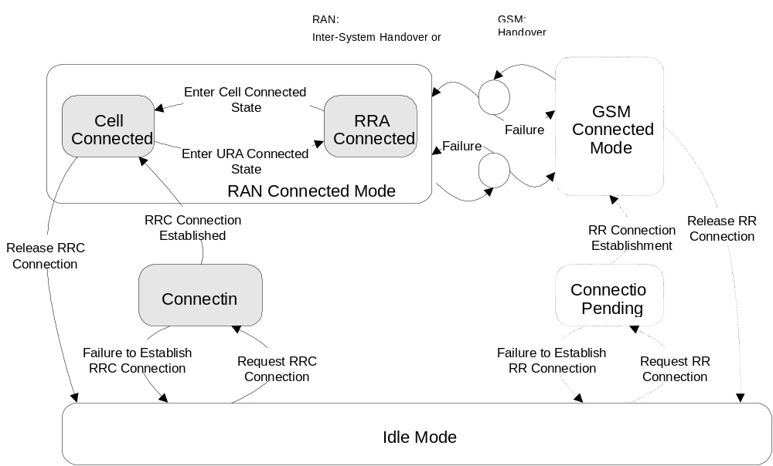

Figure 1: UE RRC States and State Transitions including GSM (PSTN/ISDN only)
It shall be noted that not all states may be applicable for all UE connections. For a given QoS requirement on the UE connection, only a subset of the states may be relevant.
After power on, the UE stays in Idle Mode until it transmits a request to establish an RRC Connection. In Idle Mode the connection of the UE is closed on all layers of the RAN. In Idle Mode the UE is identified by non-access stratum identities such as IMSI, TMSI and P-TMSI. In addition, the RAN has no own information about the individual Idle Mode UEs, and it can only address e.g. all UE:s in a cell or all UEs in a paging group. The UE behaviour within this mode is described in [4].
The Connected Mode is entered when the RRC Connection is established. This is done via the Connecting State. The UE is assigned a radio network temporary identity (RNTI) to be used as UE identity on common transport channels. [Note: The exact definition of RRC connection needs further refinement.] The main RRC states within Connected Mode reflect the level of UE connection.
For inactive stationary data users the UE may fall back to PCH in both Cell Connected and RRA Connected States. That is, upon the need for paging, the RAN shall check the current level of connection of the given UE, and decide whether the paging message shall be sent within the RRA, or should it be sent via a specific cell.
The UE states indicated between RAN Connected Mode and GSM Connected Mode are transition states where the UE, in case of failure, has the possibility to re-establish the connection in the mode it originated from.
When using PSTN / ISDN domain services, RAN is using an Inter-System Handover Procedure and GSM is using a Handover procedure for the transition from RAN Connected Mode to GSM Connected Mode.

UE RRC States and State Transitions including GSM / GPRS (IP only)
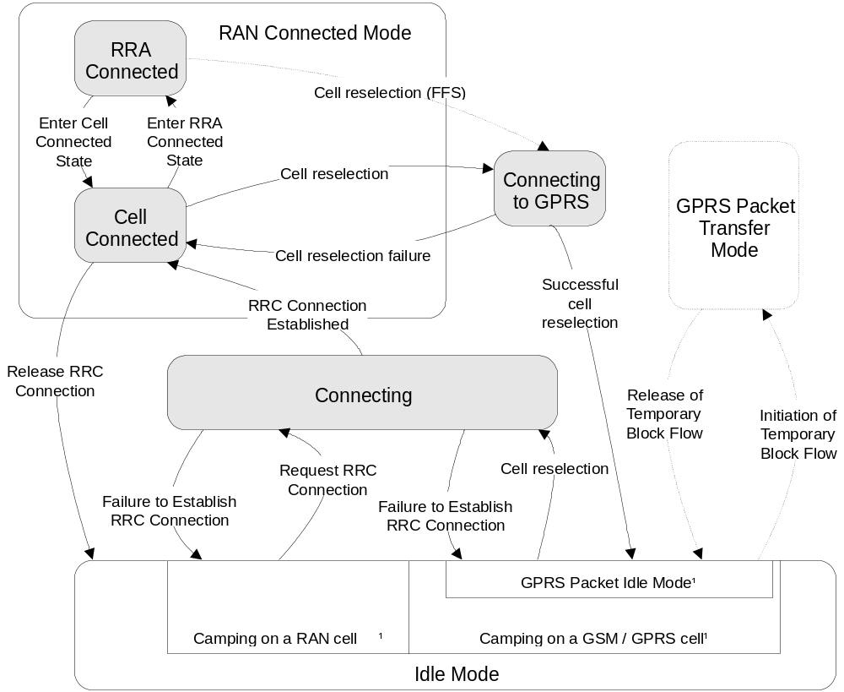

Figure 2: UE RRC states and State Transitions including GSM/GPRS (IP only)
[¹: The indicated “Radio access modes” in Idle Mode are only included for clarification and shall not be interpreted as states.]
The UE states “Connecting to GPRS” and “Connecting” indicated in figure 2 between RAN Connected Mode and Idle mode (GPRS Packet Idle Mode) are transition states where the UE, in case of failure, has the possibility to re-establish the connection in the mode it originated from.
When using IP domain services, The UE initiates cell reselection from GSM/GPRS to change from Idle Mode to “Connecting” state, from that state the UE is using the RRC Connection Establishment procedure for the transition from “Connecting” to Cell Connected state.
When the RRC Connection is established from Idle Mode (GPRS Packet Idle Mode) the RRC Connection request message contains an indication, that RAN needs to continue an already established GPRS UE context from the CN. This indication allows RAN to e.g. prioritize the RRC Connection request from the UE.
In Cell Connected or RRA Connected (ffs) State RAN is using UE or Network initiated cell reselection to change from Cell Connected or RRA Connected (ffs) state to “Connecting to GPRS” state. If the cell reselection was successful the UE enters Idle Mode (GPRS Packet Idle Mode). The UE sends a packet channel request from Idle Mode (GPRS Packet Idle mode) to establish a Temporary Block flow and enter GPRS Packet Transfer Mode. In the GPRS Packet Transfer Mode the UE sends a RA Update request message. The RA Update Request message sent from the UE contains an indication that GSM/GPRS need to continue an already established RAN UE context from the CN. This means that the RA Update request is always sent for the transition from RAN Connected Mode to GSM/GPRS regardless if the RA is changed or not.
[Note: The reason for using RA update instead of a new message is to reduce the impact on the existing GSM/GPRS specification.]

Transition from Idle Mode to Connecting State
The transition to the Connecting State from the Idle Mode can only be initiated by the UE by transmitting a request for an RRC Connection. The event is triggered either by a paging request from the network or by a request from upper layers in the UE.

Connecting State
In the Connecting State (Figure 3) the UE has transmitted a request for an RRC connection and it waits for a response. No mobility procedures take place in this state.
In this state, the UE transmits on RACH transport channel in the uplink and receives the FACH transport channel in the downlink. Only the logical channel CCCH can be used, since no RNTI is assigned. Connecting state is shown in Figure 3.
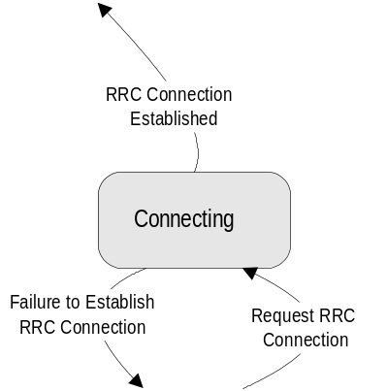
Figure 3: Connecting State

Transition to Connected Mode
When the UE receives a message from the network that confirms the RRC connection establishment, the UE enters the cell connected state. According to allocated transport channel type, UE enters RACH+(USCH)/FACH, RACH+(USCH)/DSCH or control only substate.

Transition to Idle Mode
In the case of a failure to establish the RRC Connection the UE goes back to Idle Mode. Possible causes are radio link failure, a received reject response from the network or lack of response from the network (timeout).

Connected Mode States and Transitions

Cell Connected State
In this state, the position of the UE is known on cell level. The RRC Connection mobility is handled by handover procedures including soft handover, hard handover, baton handover and cell updates. Both uplink and downlink data transfer is possible.

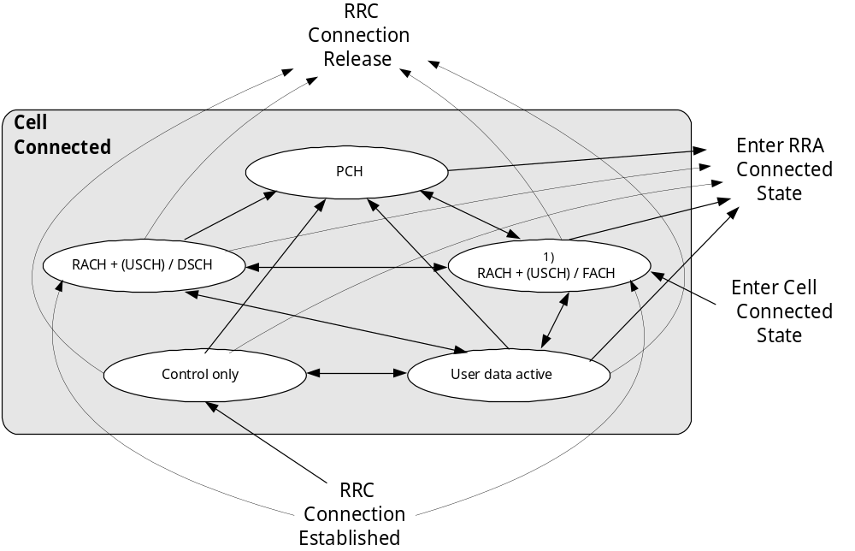

Figure 4: Substates within Cell Connected State
[¹⁾: The channels shown in parenthesis (USCH) are available in these substates after allocation to the UE.]

5.5.1.1 Control only substate

In control only substate, the uplink and downlink DCHs are allocated, but no user data frame can be exchanged with the exception of data that uses the signalling connection. Signalling in the substate includes link maintenance and higher layer signalling. Only uplink and downlink DCHs are available in control only substate.
The Control only substate is provided to save air interface capacity and provide efficient packet transfer capacity allocation.

Transition from Control only substate to User data active substate
This transition is realised by activating DTCH. According to the QoS parameter of user traffic data, proper modification such as establishment of DSCH or reconfiguration of DCH is performed during this transition. This transition can occur via explicit signalling.

Transition from Control only substate to PCH
This transition is realised through release of uplink and downlink DCHs and activating the cell update procedure. This transition can occur either
- through the expiration of the inactivity timer(T_{COS}) or
- via explicit signalling.

Transition from Control only substate to RRA connected state
This transition is realised through release of uplink and downlink DCHs and activating the URA update procedure. This transition can occur either
- through the expiration of the inactivity timer(T_{COS}) or
- via explicit signalling.

Transition from Control only substate to Idle mode
This transition is realised through release of RRC connection.

5.5.1.2 User data active substate
In this substate RAN has allocated transmission resources for the UE and it may transmit data without a prior request up to the peak capacity that is currently granted to that UE.
This substate is divided into three sub-substates according to the type of assigned transport channels. In DCH/DCH+DSCH or DCH/DSCH+DSCH Ctrl sub-substate some part or all of the DTCH resources can be allocated from the DSCH, whereas all of the DTCH resources are allocated from DCH in DCH/DCH sub-substate.
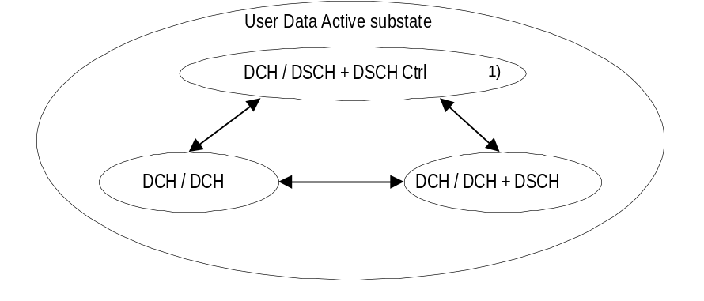
Figure 5. Sub-substates of User Data Active substate
[¹⁾: Inclusion of the DCH / DSCH + DSCH Ctrl sub-substate is based on the assumption that DSCH Ctrl contains power control bits. If these PC bits don’t exist, this substate is not needed.]

5.5.1.2.1Transition from User data active substate to control only substate
This transition is realised by inactivating DTCH. The resource which has been allocated for user traffic data is released during this transition. This transition can occur either
- through the expiration of the inactivity timer(T_{UDAS})
- at the end of the time period for which the dedicate/shared channel was allocated or
- via explicit signalling.

5.5.1.2.2Transition from User data active substate to RACH + (USCH) / FACH or RACH + (USCH) / DSCH
This transition is realised by replacing the dedicated transport channels with common transport channels. The cell update procedure is also activated during this transition. This transition can occur either
- through the expiration of an inactivity timer (T_{UDAS})
- at the end of the time period for which the dedicate/shared channel was allocated or
- via explicit signalling.

5.5.1.2.3Transition from User data active substate to PCH
This transition is realised by release of uplink/downlink DCHs, uplink/downlnk DCHs and DSCH, or uplink DCH and DSCH + DSCH ctrl. The cell update procedure is also activated. This transition can occur either
- through the expiration of an inactivity timer (T_{UDAS}) or
- via explicit signalling.

5.5.1.2.4Transition from User data active substate to RRA connected state
This transition is realised by release of uplink/downlink DCHs, uplink/downlnk DCHs and DSCH, or uplink DCH and DSCH + DSCH ctrl. The RRA update procedure is also activated. This transition can occur either
- through the expiration of an inactivity timer (T_{UDAS}) or
- via explicit signalling.

5.5.1.2.5Transition from User data active substate to Idle mode
This transition is realised by release of RRC connection.

5.5.1.2.6Transition between substates

5.5.1.2.6.1Transition from DCH/DCH to DCH/DCH+DSCH substate

Transition from DCH/DCH to DCH/DCH+DSCH substate occurs when DSCH is allocated.5.5.1.2.6.2Transition from DCH/DCH+DSCH to DCH/DCH substate

Transition from DCH/DCH+DSCH to DCH/DCH substate occurs when DSCH is released.

5.5.1.2.6.3Transition from DCH/DCH to DCH/DSCH+DSCH Ctrl substate
.
Transition from DCH/DCH to DCH/DSCH+DSCH Ctrl substate occurs when DCH in downlink is released and DSCH +DSCH Ctrl are allocated..

5.5.1.2.6.4Transition from DCH/DSCH+DSCH Ctrl to DCH/DCH substate

Transition from DCH/DSCH+DSCH Ctrl to DCH/DCH substate occurs when DSCH +DSCH Ctrl are released and DCH is allocated in downlink.

5.5.1.2.6.5Transition from DCH/DCH+DSCH to DCH/DSCH+DSCH Ctrl substate

Transition from DCH/DCH+DSCH to DCH/DSCH+DSCH Ctrl substate occurs when DCH in downlink is released and DSCH Ctrl are allocated..

5.5.1.2.6.6Transition from DCH/DSCH+DSCH Ctrl to DCH/DCH+DSCH substate

Transition from DCH/DSCH+DSCH Ctrl to DCH/DCH+DSCH substate when DSCH Ctrl is released and DCH in downlink are allocated..

5.5.1.2.7Radio Resource Allocation tasks (Control only and User data active)
For the DCH, several physical channel allocation strategies may be applied. The allocations can be either permanent (needing a DCH release message) or based on time or amount-of-data.
Resource allocation can be done separately for each packet burst with fast signalling on the DCH. Transition out of the Control only state is either triggered by user capacity allocation or by timeout (no data transaction requests received within a specified time period).
For each radio frame the UE and the network indicate the current data rate (in uplink and downlink respectively) using the transport format combination indicator (TFCI).(ffs) If the configured set of combinations (i.e. transport format set for one transport channel) are found to be insufficient to retain the QoS requirements for a transport channel, the network initiates a reconfiguration of the transport format set (TFS) for that transport channel. This reconfiguration can be done during or in between data transmission. Further, the network can reconfigure the physical channel allowing an increase or decrease of the peak data rate.
For the uplink data transmission, the UE reports the observed traffic volume to the network in order for the network to re-evaluate the current allocation of resources. This report contains e.g. the amount of data to be transmitted or the buffer status in the UE.
If during data transfer the UE is unable to transmit at the requested output power when using the peak allocated capacity, the UE shall reduce transmission rate within the current 10 ms radio frame in order to maintain the closed-loop power control.
For codecs that support variable-rate operation the UE shall be allowed to reduce transmission rate independently without requesting a new codec mode from the NW side within the limits defined by the NW in the current TFS for the impacted radio bearer.
The codec mode adaptation in the UE may be initialised e.g. when the maximum power level has been reached, or it is otherwise preferable from the UE point of view to decrease the power consumption by decreasing the data rate. The new Codec mode selected by the UE is signalled to the NW by means of the TFCI.

5.5.1.2.8RRC Connection mobility tasks (Control only and User data active)
Depending on the amount and frequency of data macrodiversity (soft handover) may or may not be applied.
The RRC Connection mobility is handled by measurement reporting, soft handover and hard handover procedures.

5.5.1.2.8.1Localised Service Area (LSA) support
In case of a network-controlled handover procedure, RAN shall take into account the local support of LSA service and the enventual subscription information of the UE to those LSA regarding the provision of service to the UE.
Regarding soft handover, the following principles are applied by RAN:
- For "LSA only" UE, the RRC connection shall be maintained by RAN as long as at least one cell of the active set belongs to a UE subscribed LSA.
- For "LSA exclusive access" cells, RAN shall prevent such cell from being part of the active set if the UE has not subscribed to the corresponding LSA
Regarding network controlled hard handover, the following principles are applied by RAN:
- For "LSA only" UE, RAN shall prevent the UE from being handed over a cell which does not belong to a UE subscribed LSA.
- For "LSA exclusive access" cells, RAN shall prevent the UE from being handed over such a cell if the UE has not subscribed to the corresponding LSA

5.5.1.2.9 Transfer and update of system information ( Control only and User data active )

UEs with certain capabilities shall read system information broadcast on FACH. For each acquisition, the UE may need different combinations of system information broadcast on BCH. The scheduling on the broadcast channel is done in such way that the UE knows the request information can be found.

.5.5.1.3RACH / FACH and RACH + USCH / FACH substates
[Note: Channels in parenthesis available after allocation.]
The position of the UE is known by RAN on cell level. In the RACH / FACH substate the UE performs the following actions:
- listens to an FACH
- listens to the BCH transport channel of the serving cell for the decoding of system information messages (ffs)
- initiates a cell update procedure on cell change
- transmits uplink control signals and small data packets on the RACH.
- transmits uplink control signals and larger data packets on USCH when resources are allocated to cell and UE is assigned use of those USCH resources.

Furthermore, the UE can use the USCH to trigger the allocation of a new DCH by RNC. Further rate adaptation can be done via the DCCH of the new DCH.

5.5.1.3.1Transition from RACH/FACH to RACH+USCH/FACH substate

Transition from RACH/FACH to RACH+USCH/FACH substate occurs when USCH is allocated.

5.5.1.3.2Transition from RACH+USCH/FACH to RACH/FACH substate

Transition from RACH+USCH/FACH to RACH/FACH substate occurs when USCH is released.

5.5.1.3.3Transition from RACH/FACH to User data active substates

A transition occurs, when a dedicated transport channel is established via explicit signalling. Examples of these procedures are given in section 7.2.3.
Details of the transition to User data active substate FFS.
The transition can occur via explicit signalling.

5.5.1.3.4Transition from RACH+USCH/FACH to User data active substates
Transition from RACH+USCH/FACH to User data active substates occurs when RACH,USCH and FACH are released and DCH ,DSCH are allocated.

5.5.1.3.5Transition from RACH/FACH or RACH+USCH/FACH to PCH substate
Since the UE performs continuous reception of FACH in this substate, it should be moved to the PCH substate if the data service has not been active for a while. When an inactivity timer (T_{rf}) expires, the UE state is changed to PCH in order to decrease power consumption. Also, when coming from PCH substate, and after the cell update procedure has been performed, the UE state is changed back to PCH substate if neither the UE nor the network has any data to transmit.
When coming from RACH+USCH/FACH substate, the USCH is still availiable in the PCH substate after the transition.

5.5.1.3.6Transition from RACH/FACH or RACH+USCH/FACH to Idle Mode
The release of the RRC connection moves the UE to the idle mode.

5.5.1.3.7Transition from RACH/FACH or RACH+USCH/FACH to RACH / DSCH or RACH+USCH / DSCH state

Transition from RACH/FACH or RACH+USCH/FACH to RACH / DSCH state occurs when USCH and FACH are released and DSCH is allocated.

5.5.1.3..8Transition from RACH/FACH or RACH+USCH/FACH to RRA Connected State
To perform the RRA update procedure, UE is moved temporarily from RRA Connected to RACH / FACHUSCHsubstate. After the RRA update is completed, UE state is changed back to RRA Connected.
If USCH is intended to be used in RRA Connected State, a USCH transport channel needs to be allocated for the intended cells in the RRA prior to this transition.

5.5.1.3.9Radio Resource Allocation Tasks (RACH/FACH)
In the RACH / FACH substate the UE will monitor an FACH. It is enabled to transmit uplink control signals and it may be able to transmit small data packets on the RACH. The network can assign the UE stransport channel parameters (e.g. transport format sets) in advance, to be used when a DCH is used. When the physical channel for DCH is assigned, the transport channel type is switched to DCH and the assigned TFS can be used.
When there is either user or control data to transmit, a selection procedure determines whether the data should be transmitted on a common transport channel, or if a dedicated transport channel should be allocated. The selection should be dynamic and depend on traffic parameters (amount of data, packet burst frequency).

5.5.1.3.10Radio Resource Allocation Tasks (RACH+USCH/FACH)
The RAN can assign USCH resources to the UE in RACH/FACH substate. When USCH resources are assigned, the UE will continue to monitor FACHs. The UE may use the RACH to transmit uplink control signals and small data packets. The UE also may choose to transmit data packets, larger than those carried on the RACH, on the USCH channel. The UE selects either the RACH or one of the USCH channels to make maximum use of the capacity available on that channel.
The UE provides the RAN with USCH measurement data which includes data queue depth (current size of data buffers), average access time for each USCH channel used, and average traffic volume on each USCH channel used. With these measurements and the RAN MAC-d measurement reports, the RAN can reallocate network resources on a periodic basis. The RAN allocates USCH Sets to each cell and assigns UEs to one of the cell’s USCH Sets. The UEs can dynamically access the USCH resources without further RAN control.

5.5.1.3.11RRC Connection mobility tasks (RACH + (USCH)/FACH)
[Note: Channels in parenthesis available after allocation.]
In this substate the location of the UE is known on cell level. A cell update procedure is used to report to the RAN, when the UE selects a new cell to observe the common downlink channels of a new Node B. In this substate measurement reporting and hard handover procedures can be used. Downlink data transmission on the FACH can be started without prior paging.
In RACH / FACH substate an RACH / FACH cell set comparable to the active set of a dedicated channel in SHO is maintained both in the UE and in the network. The RACH / FACH cell set representes a list of cells which have the potential to serve the UE from radio signal strength perspective. The UE performs measurements and reporting for the RACH / FACH cell set using the same procedures as in DCH/DCH+DSCH substates. The thresholds required for triggering a measurement report may be different from those in DCH-based substates.
The RACH/FACH cell set information is used by the network to decide whether the user data can be routed directly via a cell to a specific UE or soft handover would be required when resuming the DCH operation. In addition, the RACH/FACH cell set information provides the means for the network to evaluate potential interference conditions and select a suitable amount of capacity when moving the UE in the DCH active substate, for both uplink and downlink data transfer.
The UE monitors the broadcast channel and system information on BCCH of its own and neighbour cells and from this the need for the updating of cell location is identified.

5.5.1.3.12 Transfer and update of system information ( RACH+(USCH)/FACH )

The UEs shall read the BCH to acquire valid system information. For each acquisition, the UE may need different combinations of system information broadcast on BCH. The scheduling on the broadcast channel is done in such way that the UE knows the request information can be found.
When the system information is modified, the scheduling information is updated to reflect the changes in system information transmitted on BCH. The new schduling information is broadcast on FACH in order to inform UEs about the changes. If the changes are applicable for the UE, the modified system information is read on BCH.

5.5.1.4RACH/DSCH and RACH+USCH/DSCH substates

The position of the UE is known by RAN on cell level. In the RACH / DSCH substate the UE performs the following actions:
- listens to an DSCH
- listens to the BCH transport channel of the serving cell for the decoding of system information messages (ffs)
- initiates a cell update procedure on cell change
- transmits uplink control signals and small data packets on the DSCH.
- transmits uplink control signals and larger data packets on USCH when resources are allocated to cell and UE is assigned use of those USCH resources.

Furthermore, the UE can use the USCH to trigger the allocation of a new DCH by RNC. Further rate adaptation can be done via the DCCH of the new DCH.
State transitions need to FFS.

5.5.1.5PCH substate
The position of the UE is known by RAN on cell level. In this substate the UE performs the following actions:
- listens to the PCH transport channel for the decoding of paging and notification messages sent by the network
- listens to the BCH transport channel of the serving cell for the decoding of system information messages
- initiates a cell update procedure on cell change.
The DCCH logical channel cannot be used in this substate. If the network wants to initiate any activity, it needs to make a paging request on the PCCH logical channel in the known cell to initiate any downlink activity.

5.5.1.5.1Transition from PCH to RRA Connected State
The only overhead in keeping a UE in the PCH substate is the potential possibility of cell updating, when the UE moves to other cells.
To reduce this overhead, the UE is moved to the RRA Connected State when low activity is observed. This can be controlled with an inactivity timer, and optionally, with a counter which counts the number of cell updates. When the number of cell updates has exceeded certain limits (a network parameter), then the UE changes to the RRA Connected State.
[Editor’s note: If the coverage area of USCH is expanded from one cell to several cells in the RRA in relation to the execution of this transition, the new USCH allocation information for each new cell in the RRA needs to be exchanged either in RACH+USCH/FACH or a DCH-based substate prior to a transition from PCH to RRA connected state. For proper operation, this shouldn’t be observed as increased activity.]

5.5.1.5.2Transition from PCH to RACH/FACH substate
The UE is transferred to RACH/FACH substate either by a command (packet paging) from RAN or through any uplink access.

5.5.1.5.3Transition from PCH to RACH+USCH/FACH substate
If a valid USCH transport channel is allocated for the current cell, the UE changes to RACH+USCH/FACH substate as soon as it uses the USCH to allocate a DCH.

5.5.1.5.4Transition from PCH to RACH/DSCH or RACH+USCH/DSCH substates
Transition from PCH to RACH/DSCH or RACH+USCH/DSCH substates occurs when RACH, USCH and DSCH are allocated.

5.5.1.5.5Radio Resource Allocation Tasks (PCH)
In PCH substate no resources have been granted for data transmission. For this purpose, a transition to another substate has to be executed.

5.5.1.5.6RRC Connection mobility tasks (PCH)
In the PCH substate, the UE mobility is performed through cell reselection procedures.
Cell updating is initiated by the UE which, upon the detection of the new cell, moves to RACH/FACH substate and initiates a cell update procedure in the new cell. After the cell update procedure has been performed, the UE state is changed back to PCH substate if neither the UE nor the network has any more data to transmit.

5.5.1.5.7 Transfer and update of system information ( PCH )

The UEs shall read the BCH to acquire valid system information. For each acquisition, the UE may need different combinations of system information broadcast on BCH. The scheduling on the broadcast channel is done in such way that the UE knows the request information can be found.

RRA Connected State
In RRA Connected State (Figure 5) the location of a UE is known on RAN Registration area level.
In this substate the UE performs the following actions:
- listens to the PCH transport channel for the decoding of paging and notification messages sent by the network
- listens to the BCH transport channel of the serving cell for the decoding of system information messages
- initiates a RRA updating procedure on RRA change.
The DCCH logical channel cannot be used in this substate. If the network wants to initiate any activity, it needs to make a paging request on the PCCH logical channel within the RRA where the location of the UE is known. If the UE needs to transmit anything to the network, it goes to the RACH/FACH substate of the Cell Connected State. In addition, the UE can also use the USCH for requesting a DCH in the whole RRA or parts of it, if the UE has been allocated - on entering the connected mode or via explicit signalling later on - a USCH channel for the cell, which the UE is currently camping on.
The transition to RRA Connected State can be controlled with an inactivity timer, and optionally, with a counter which counts the number of cell updates. When the number of cell updates has exceeded certain limits (a network parameter), then the UE changes to the RRA Connected State.
RRA updating is initiated by the UE which, upon the detection of the Registration area, sends the network the Registration area update information on the RACH of the new cell.
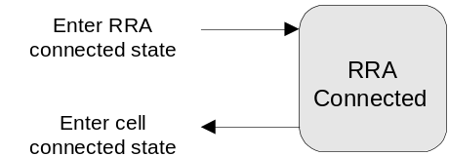
Figure 5: RRA Connected State

Transition from RRA Connected State to Cell Connected State
Any activity causes the UE to be transferred to RACH / FACH or RACH + USCH / FACH substate of the Cell Connected State. Uplink access is performed by either RACH or USCH, if a USCH transport channel for the current cell has been allocated.
Note that the release of an RRC connection is not possible in the RRA Connected State. The UE will first move to Cell Connected State to perform the release signalling.

Radio Resource Allocation Tasks (RRA Connected)
In RRA Connected State no resources have been granted for data transmission. For this purpose, a transition to a suitable substate of Cell Connected State has to be executed.

RRC Connection mobility tasks (RRA Connected)
In RRA Connected State the location of a UE is known on RAN Registration area level.
In this state, the UE mobility is performed through RRA reselection procedures, which may differ from the definitions in 3GPP S2.04. If the new cell belongs to a different RRA, the UE moves to RACH/FACH substate of the cell connected state and initiates a RRA update towards the network. After the RRA update procedure has been performed, the UE state is changed back to RRA connected state if neither the UE nor the network has any more data to transmit.

Transfer and update of system information ( RRA connected )

The UEs shall read the BCH to acquire valid system information. For each acquisition, the UE may need different combinations of system information broadcast on BCH. The scheduling on the broadcast channel is done in such way that the UE knows the request information can be found.

Inter-system handover with simultaneous IP and PSTN/ISDN domain services
[Note: This is an initial assumption that needs to be seen by SMG2 and requiring checking by SMG2, when the work on this item has progressed.]

Inter-system handover TD-SCDMA RAN to GSM / BSS
For a UE in cell Connected state on a dedicated channel using both PSTN / ISDN and IP Domain services the Inter-system handover procedure is based on measurement reports from the UE but initiated from RAN.
The UE performs the Inter-system handover from RAN Connected Mode to GSM Connected Mode first. When the UE has sent handover complete message to GSM / BSS the UE initiates a temporary block flow towards GPRS and sends a RA update request.
If the Inter-system handover from RAN Connected Mode to GSM Connected Mode was successful the handover is considered as successful regardless if the UE was able to establish a temporary block flow or not towards GPRS.
In case of Inter-system handover failure the UE has the possibility to go back to RAN Connected Mode and re-establish the connection in the state it originated from without attempting to establish a temporary block flow. If the UE has the option to try to establish a temporary block flow towards GSM / GPRS after Inter-system handover failure is FFS.

Inter-system handover GSM / BSS to TD-SCDMA RAN
For a UE in GSM Connected Mode using both PSTN / ISDN and IP domain services the Inter-system handover procedure is based on measurement reports from the UE but initiated from GSM / BSS.
The UE performs the Inter-system handover from GSM Connected Mode to RAN Connected Mode.
In RAN Connected Mode both services are established in parallel.
If the Inter-System handover from GSM Connected mode to RAN Connected Mode was successful the handover is considered as successful.
In case of Inter-system handover failure the UE has the possibility to go back to GSM Connected Mode and re-establish the connection in the state it originated from.

Radio Bearer Control – Overview of Procedures

Configurable parameters
The following layer 1, MAC and RLC parameters should be able to configure by RRC. The list is not complete.
- Radio bearer parameters, e.g.
- RLC parameters per RLC link (Radio bearer), which may include e.g. PDU size and timeout values. Used by RLC.
- Multiplexing priority per DCCH/DTCH. Used by MAC in case of MAC multiplexing of logical channels.
- Transport channel parameters, e.g.
- Scheduling priority per transport channel. Used by MAC in case of layer 1multiplexing of transport channels.
- Transport format set (TFS) per transport channel. Used by MAC and L1.
- Transport format combination set (TFCS) per UE. Used by MAC and L1.
- Allowed subset of TFCS per UE. Used by MAC.
- USCH access parameters per USCH channel. [Details are FFS.] Used by MAC and L1.
- Physical channel parameters, which may include e.g. carrier frequency and codes. Used by L1.

Typical configuration cases
The table below gives a proposal which main combination cases of parameter configuration that shall be supported, in terms of which parameters that shall be able to configure simultaneously (by one procedure). Note that the “Transport channel type switching” is not a parameter as such, it only indicates that switching of transport channel type may take place for that combination case.
Parameter |  | Layer | A | B | C | D | E |  | F
Radio bearer parameters | RLC parameters | RLC | X
 | Logical channel multiplexing priority | MAC | X
Transport channel parameters | Transport channel scheduling priority | MAC | X
 | TFS | L1+MAC | X | X
 | TFCS | L1+MAC | X | X
 | Subset of TFCS | MAC |  |  |  |  | X | X
 | Transport channel type switching | MAC | X | X | X
Physical channel parameters |  | L1 | X | X | X | X

Table 1. Typical configuration cases. An “X” indicates that the parameter can (but need not) be configured.
Case A is typically when a radio bearer is established or released, or when the QoS of an existing radio bearer or the signalling link need to be changed (the necessity of change of QoS is FFS).
Case B is when the traffic volume of a radio bearer has changed so the TFS used on the DCH need to be changed, which may in turn affect any assigned set of physical channels. Another example is to make the UE use a new transport channel and at the same time supplying the TFS for that channel.
Case C is when the traffic volume of one radio bearer has changed so that the used transport channel type is changed, e.g. from RACH/FACH to DCH/DCH or when the USCH Set assigned to a UE is switched. This case includes the assignment or release of a set of physical channels.
Case D is e.g. the change of used DL channelization code, when a DCH is currently used. No transport channel type switching take place.
Case E is a temporary restriction and/or a release of restriction for usage of the TFCS by the UE (total uplink rate).
Case F is used to dynamically control the allocation of resources on uplink DCHs in the CRNC, using broadcast information such as transmission probability and maximum bit rate.

RRC Elementary Procedures

Category 1: Radio Bearer Configuration
The first category of procedures includes Case A and are characterized by:
- Are executed upon request by higher layers and the parameter configuration is based on QoS
- Affects L1, MAC and RLC.
There are three RRC procedures included in this category:
- Radio Bearer Establishment. This procedure establishes a new Radio Bearer. The establishment includes, based on QoS, assignment of RLC parameters, multiplexing priority for the DTCH, USCH Set assignment, scheduling priority for DCH, TFS for DCH and update of TFCS. It may also include assignment of a physical channel(s) and change of the used transport channel types / RRC state.
- Radio Bearer Release. This procedure releases a radio bearer. The RLC entity for the radio bearer is released. The procedure may also release a DCH, which affects the TFCS. It may include release of physical channel(s) and change of the used transport channel types / RRC state.
- Bearer Reconfiguration. This procedure reconfigures parameters for a radio bearer or the signalling link to reflect a change in QoS. It may include change of RLC parameters, change of multiplexing priority for DTCH/DCCH, USCH Set assignment, change of DCH scheduling priority, change of TFS for DCH, change of TFCS, assignment or release of physical channel(s) and change of used transport channel types. [Note: The necessity of this procedure is FFS.]

Category 2: Transport Channel Configuration
The second category of procedures includes Case B and are characterized by:
- Configuration of TFS for a transport channel and reconfiguration of TFCS is done, but sometimes also physical channel parameters.
- Affects L1 and MAC.
- Switching of used transport channel(s) may take place.
There is one RRC procedure included in this category:
- Transport Channel Reconfiguration. This procedure reconfigures parameters related to a transport channel such as the TFS. The procedure also assigns a TFCS and may change physical channel parameters to reflect a reconfiguration of a transport channel in use. [Note: It is expected that the configuration of TFS/TFCS needs to be done more seldom than the assignment of physical channel. A “pre-configuration” of TFS/TFCS of a transport channel not in use can be done by this procedure, to be used after transport channel type switching when the physical channel is assigned.]

Category 3: Physical Channel Configuration
The third category of procedures includes the cases C and D and are characterized by:
- May assign or release a physical channel for the UE (which may result in transport channel type switching)
- May make a combined release and assignment (replacement) of a physical channel in use (which does not result in transport channel type switching / change of RRC state).
- Affects mainly L1, and only the transport channel type switching part of MAC.
- The transport format sets (TFS and TFCS) are not assigned by this type of procedure. However, the UE can be directed to a transport channel, which TFS is already assigned to the UE.
There is one RRC procedure included in this category:
- Physical Channel Reconfiguration. This procedure may assign, replace or release a set of physical channels used by an UE. As a result of this, it may also change the used transport channel type (RRC state). For example, when the first physical channel is assigned the UE enters the DCH/DCH state. When the last physical channel is released the UE leaves the DCH/DCH state and enters a state (and transport channel type) indicated by the network. A special case of using this procedure is to change the DL channelization code of a dedicated physical channel. [Note: The procedure does not change the active set, in the downlink the same number of physical channels are added or replaced for each radio link.]

Category 4: Transport Format Combination Restriction
The fourth category of procedures includes Case E and are characterized by:
- Does only control MAC by means of the transport format combinations that may be used within the set without affecting L1.
There is one RRC procedure included in this category:
- Transport format combination control. The network uses this procedure towards an UE, to control the used transport format combinations in the uplink within the transport format combination set.

Category 5: Uplink Dedicated Channel Control in CRNC
The fifth category of procedures includes Case F and are characterized by:
- Does control UE MAC by means of broadcasting transmission probability and maximum total bit rate that shall be used for uplink DCHs, which are under control by this procedure.
There is one RRC procedure included in this category:
- Dynamic Resource Allocation Control of Uplink DCHs : The network uses this procedure towards all UEs, to control the probability of transmission and the maximum total bit rate used by uplink DCHs, which are under control by this procedure.

Examples of procedures

These sequences are examples and do not provide a comprehensive set of all different scenarios.
In cases where the logical and / or transport channel for a given message is known, it can be shown in front of the message name (Logical_Ch: Transport_Ch: Message). For example: DCCH:RACH:Acknowledged Data indicates a data message on DCCH mapped onto RACH. Either logical or transport channel can be omitted, if it is unspecified for the message.

RRC Connection Establishment and Release Procedures

RRC connection establishment
RRC connection establishment (see /5/) is shown in Figure 6 (protocol termination for common channels is shown according to former case A, case C can be found for comparison in Annex A). The RRC layer in the UE leaves the idle mode and initiates an RRC connection establishment by sending an RRC Connection Request message using the MAC SAP for the CCCH logical channel. MAC transmits the L3 message on the RACH transport channel.
[Editor’s Note: The L23 EG has adopted a working assumption to use an identity from the Non-Access Stratum (such as TMSI+LAI) included in the RRC Connection Request message. A PRACH physical random access channel capable of transmitting 32 kbps is estimated to be suitable for the message, guidance on the preferability of this data rate is sought from the physical layer EG. Other alternatives exist, such as a random number.]
On the network side, upon the reception of RRC Connection Request, the RRC layer performs admission control, assigns an s-RNTI for the RRC connection and selects radio resource parameters (such as transport channel type, transport format sets etc). If a DCH is to be established, a CPHY-RL-Setup and CPHY-TrCH-Config request primitives (transmitted as one RADIO LINK SETUP PDU) are sent to all Node B:s which would be involved in the channel establishment. The physical layer operation is started and confirmation primitives are returned from each Node B. RRC configures parameters on layer 2 to establish the DCCH logical channel locally. The selected parameters including the RNTI, are transmitted to the UE in an RRC Connection Setup message using the MAC SAP for the CCCH logical channel.
Upon reception of the RRC Connection Setup message, the RRC layer in the UE configures the L1 and L2 using these parameters to locally establish the DCCH logical channel. In case of DCH, layer 1 indicates to RRC when it has reached synchronisation. The need for the synchronisation indication on the network side is FFS.
The RLC signalling link is locally established on both sides. The establishment can be mapped on either RACH / FACH, RACH+USCH / FACH or DCH by MAC. When the UE has established the RLC signalling link, it transmits an RRC Connection Setup Complete message to the network using acknowledged mode on the DCCH.
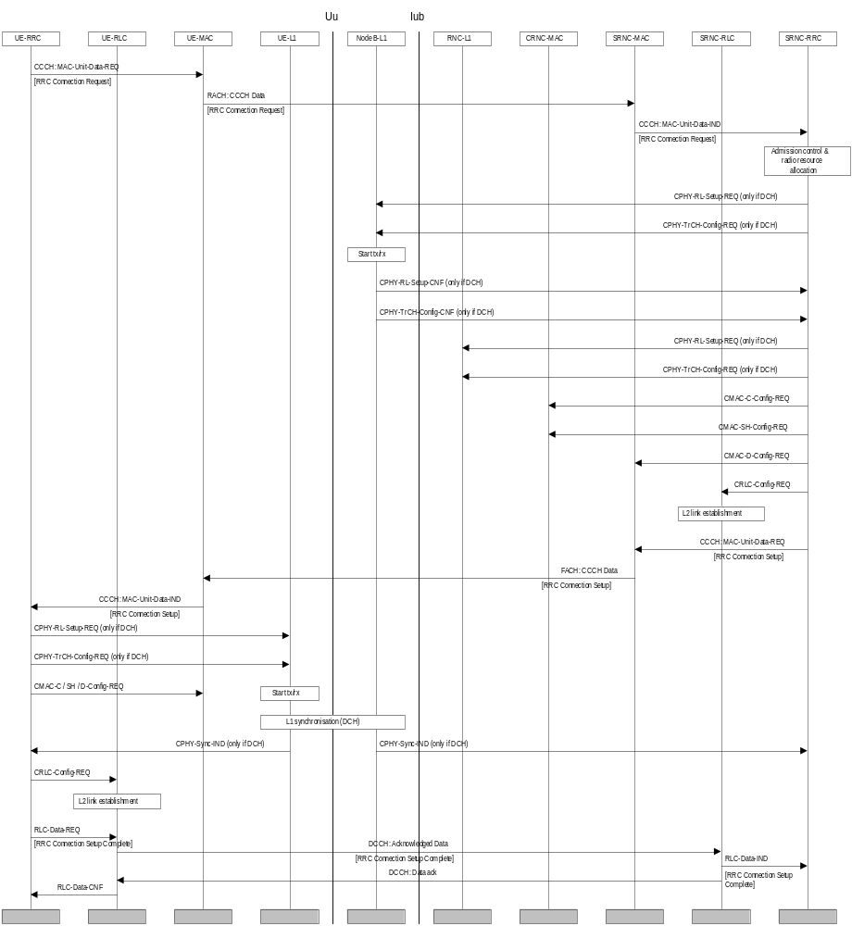
Figure 6. RRC connection establishment (with common channel termination case A)

UE Initiated Signalling Connection Establishment
[Note1: In case additional UE capability information is needed at RRC Connection Setup, it is transmitted in the RRC Connection Setup Complete message.]
The sequence in Figure 7 shows the establishment of the first Signalling Connection for the UE, initiated by the UE.
RRC Signalling Connection Establishment is requested by the non access stratum in the UE with a primitive over the Dedicated Control (DC) SAP. The primitive contains an initial message to be transferred transparently by RRC to the non-access stratum entity on the network side. [Note2: The initial NAS message could for a GSM based Core Network be e.g. CM Service Request, Location Update Request etc.]
If no RRC connection exists, the RRC layer makes an RRC connection establishment, which includes the transmission of UE capability information. When the RRC connection establishment is completed, the signalling connection establishment can be resumed.
The initial message from NAS is transferred in the RRC message “Direct Transfer” using acknowledged mode on the DCCH, to the network, where it is passed on with an RRC Signalling Connection Establish IND primitive over the DC-SAP. [Note3: The necessity for a separate RRC message for encapsulating NAS messages is FFS]. When the initial NAS message has been transferred successfully, as indicated by the RLC-Data-CNF primitive in the UE, the Signalling Connection Establishment is confirmed by the UE-RRC.
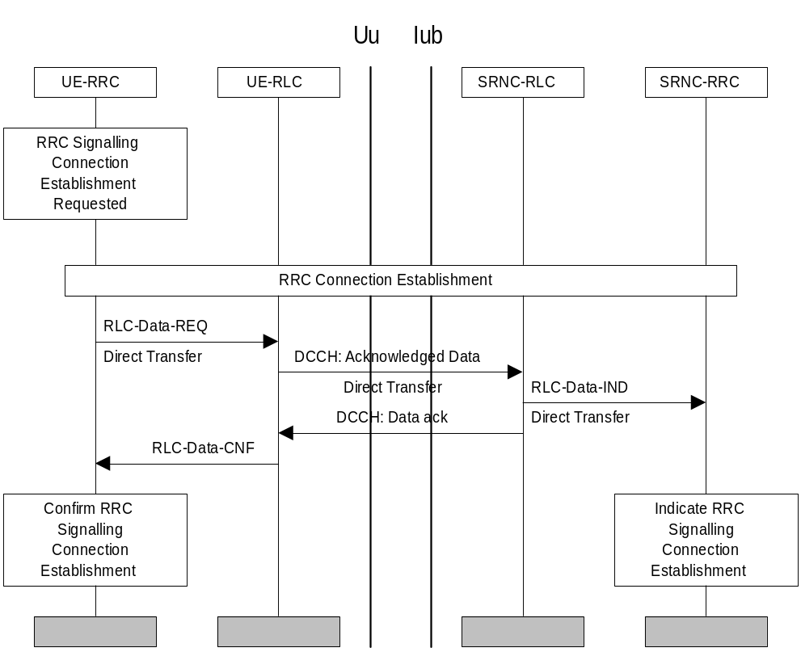
Figure 7. UE initiated Signalling Connection Establishment

Normal RRC Connection Release
A normal RRC Connection Release procedure is initiated on the network side by an RRC Signalling Connection Release request for the last Signalling Connection of a UE. The procedure is slightly different depending on whether the UE has dedicated physical channel(s) allocated.

RRC Connection Release from Dedicated Physical Channel
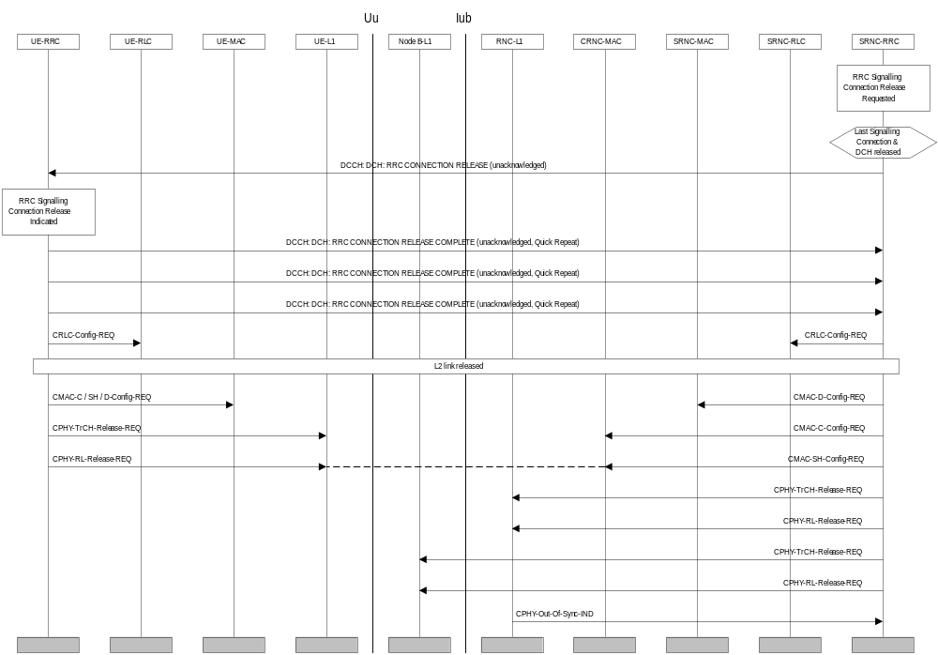
Figure 8. RRC Connection Release from Dedicated Physical Channel
The RRC layer entity in the network issues an RRC CONNECTION RELEASE message using unacknowledged mode on the DCCH. Upon reception of this message the UE-RRC sends an RRC Signalling Connection Release Indication primitive to NAS The UE replies with an RRC CONNECTION RELEASE COMPLETE message, which is sent in unacknowledged-mode on the dedicated channel. To improve the reliability of the message, quick repeat on RRC-level can be used. The UE will then proceed to release RLC(s), MAC and the radio link(s) after which the UE RRC enters Idle Mode.
The primary method to detect the release of the signalling link in the NW is the RRC CONNECTION RELEASE COMPLETE-message from the UE. Should the message be lost despite the use of quick repeat, the release of the signalling link is detected by the out-of-sync primitive from either Node-B L1 or RNC-L1 (ffs) to RNC RRC. After receiving this primitive, the RNC-RRC layer releases L2 and L1 resources on the network side and enters the idle mode.

RRC Connection Release without Dedicated Physical Channel
The RRC layer entity in the network issues an RRC CONNECTION RELEASE message using unacknowledged or acknowledged mode on the DCCH. Upon reception of this message the UE-RRC sends an RRC Signalling Connection Release Indication primitive to NAS and an RRC CONNECTION RELEASE COMPLETE message to RAN using acknowledged mode on the DCCH.
[Note: Depending on RLC design, the acknowledgement to RRC CONNECTION RELEASE could be piggybacked to the RRC CONNECTION RELEASE COMPLETE MESSAGE, resulting in no additional messages. Therefore acked / unacked transmission is considered FFS.]
After receiving the RRC CONNECTION RELEASE COMPLETE message the network RRC layer releases L2 resources, sends an RRC Signalling Connection Release confirmation to DC-SAP and goes to Idle Mode (more precisely: only the RRC entity dedicated to this UE goes to Idle Mode).

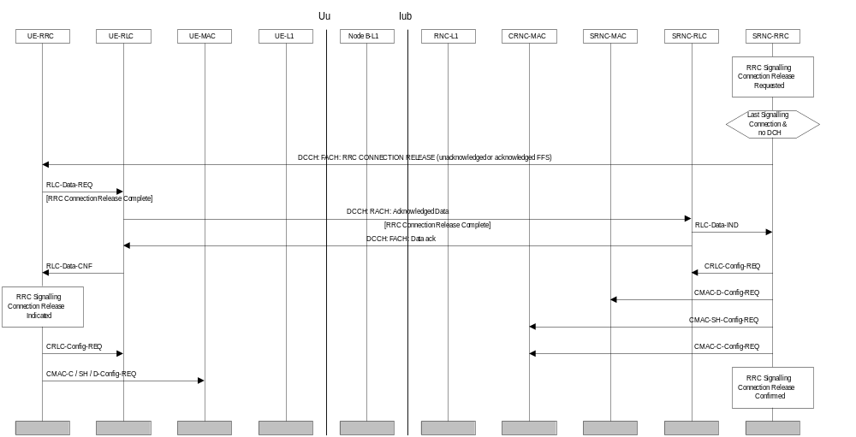
Figure 9: RRC Connection Release without Dedicated Physical Channel

Radio Bearer Procedures

Radio Bearer Configuration

Radio Bearer Establishment
The procedures for establishing radio bearers may vary according to the relation between the radio bearer and a dedicated transport channel. Depending on the QoS parameters, there may or may not be a permanently allocated dedicated channel associated with the RAB. Circuit-switched bearers, or bearers classified as real-time services typically need a permanent association to a DCH to meet the delay requirements. Packet-switched bearers, or bearers classified as non-real-time services can in many cases be served as best-effort, requesting capacity from an associated DCH based on need.
When establishing a RAB together with a DCH, the DCH may be attached to either a newly activated physical channel or it may be accommodated by modifying an existing physical channel. The modification is further broken down into two different options: synchronised and unsynchronised. If the old and new physical channel settings are compatible (TFCI etc.) in the sense that executing the modification in the NW and the UE with arbitrary timing does not introduce transmission errors, the unsynchronised procedure can be applied. If the old and new settings are incompatible, due to e.g. assignment of the same TFCI value to a new set of physical layer configuration, the synchronised procedure must be used.

Radio Bearer Establishment with Dedicated Physical Channel Activation
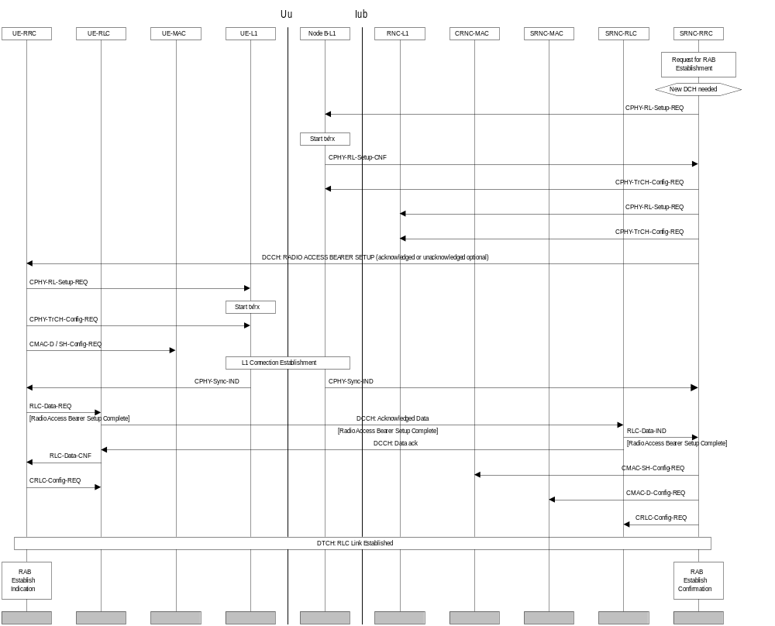
Figure 10: Radio Bearer Establishment with Dedicated Physical Channel Activation
The procedure in Figure 10 is applied when a new physical channel needs to be created for the radio bearer. A Radio bearer Establishment is initiated when an RAB Establish Request primitive is received from the DC-SAP on the network side of the RRC layer. This primitive contains a bearer reference and QoS parameters. Based on these QoS parameters, L1 and L2 parameters are chosen by the RRC entity on the network side.
The physical layer processing on the network side is started with the CPHY-RL-Setup request primitive issued to all applicable Node B:s. If any of the intended recipients is / are unable to provide the service, it will be indicated in the confirmation primitive(s).After setting up L1 including the start of tx / rx in Node B, the NW-RRC sends a RADIO BEARER SETUP message to its peer entity (acknowledged or unacknowledged transmission optional for the NW). This message contains L1, MAC and RLC parameters. After receiving the message, the UE-RRC configures L1 and MAC.
When L1 synchronisation is indicated [Note: Need for sync_ind on NW-side FFS], the UE sends a RADIO BEARER SETUP COMPLETE message in acknowledged-mode back to the network. The NW-RRC configures MAC and RLC on the network side.
After receiving the confirmation for the RADIO BEARER SETUP COMPLETE, the UE-RRC creates a new RLC entity associated with the new radio bearer. The applicable method of RLC establishment may depend on RLC transfer mode. The RLC connection can be either implicitly established, or explicit signalling can be applied. The exact procedure is FFS. [Note2: Not needed for transparent mode but may be needed for non- transparent mode.]
Finally, an RAB Establish Indication primitive is sent by UE-RRC and an RAB Establish Confirmation primitive is issued by the RNC-RRC.

Radio bearer Establishment with Unsynchronised Dedicated Physical Channel Modification
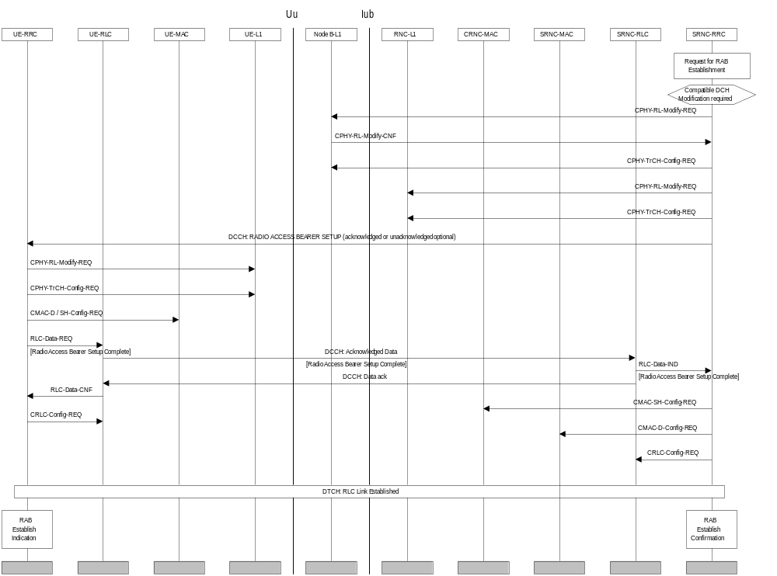
Figure 11: Radio bearer Establishment with Unsynchronised Dedicated Physical Channel Modification
The establishment of a radio bearer, when unsynchronised physical channel modification is applicable, is shown in Figure 11. If the old and new physical layer configurations are compatible in the sense that they can coexist in the peer entities, an unsynchronised procedure for radio bearer establishment can be applied. In this case no fixed activation time is required.
The modifications on the physical layer in the network are done in response to an CPHY_ modify request. Failure to comply is indicated in the confirmation primitive. In an error-free case the RADIO BEARER SETUP message on L3 is transmitted. Acknowledged or unacknowledged transmission is a network option. Configuration changes on the UE-side proceed after this message has been received. Reception of the RADIO BEARER SETUP COMPLETE message triggers configuration changes in MAC and RLC in the network.

Radio bearer Establishment with Synchronised Dedicated Physical Channel Modification
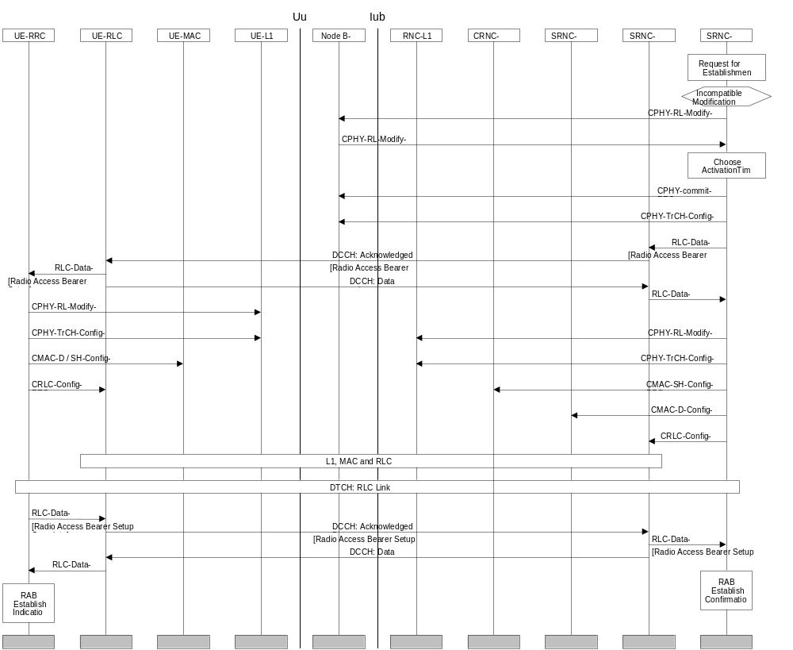
Figure 12: Radio Bearer Establishment with Synchronised Dedicated Physical Channel Modification
In case the old and the new physical channel configurations are incompatible with each other (due to different DPCCH format, TFCI patterns or similar differences), the modification on physical layer and L2 require exact synchronisation between the UE and the NW, as shown in Figure 12.
In this case the CPHY-RL-Modify request doesn’t immediately cause any changes in the physical layer configuration, it only checks the availability of the requested configuration and makes a “reservation”. After the confirmations have been received from all applicable Node B:s, the RRC chooses the appropriate “activation time” when the new configuration can be activated. This information is signalled to MAC, RLC and also the physical layer (CPHY_Commit request primitive).
After the RADIO BEARER SETUP message (acknowledged transmission on L2 required) between peer L3 entities the setup proceeds on the UE-side. The new configuration is now available both on the UE and the network side, and at the scheduled activation time the new configuration is assumed by all applicable peer entities. [Note: The method of synchronisation is a subject of current study.]

Radio Bearer Establishment without Dedicated Physical Channel
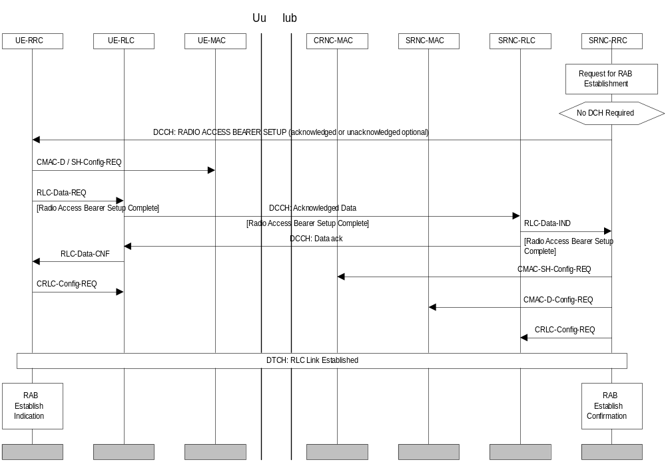
Figure 13: Radio Bearer Establishment without Dedicated Physical Channel
For some radio bearers dedicated radio resources are not permanently associated. Therefore the setting up of the physical resource is separate from the actual radio bearer setup, which involves only RLC and MAC.
MAC can be initially configured to operate either on existing dedicated transport and physical channels or on common channels.

Radio Bearer Establishment with USCH Channel Allocation
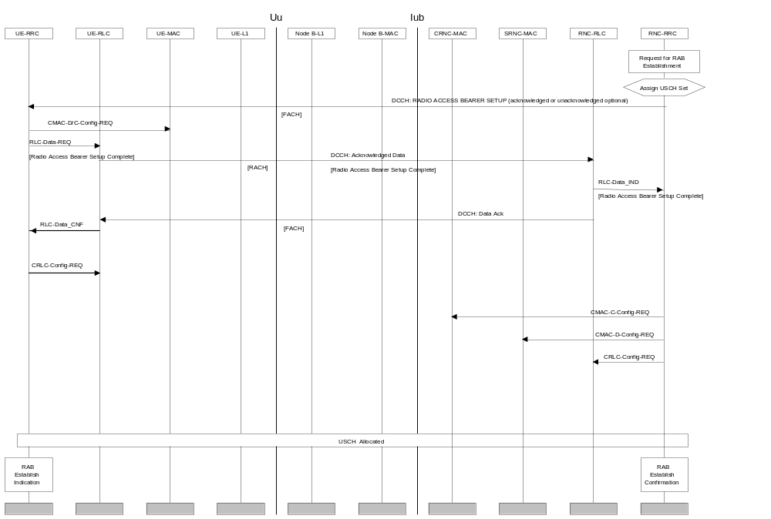
Figure 14: Radio Bearer Establishment with USCH Channel Allocation
When the RNC determines the need to assign USCH UL resources to a UE, the RNC sends a RAB Setup message to the UE. Since the USCH physical parameters are broadcast in the BCCH, the RAB Setup message does not include a DPCH part. The Transport Channel information includes the USCH set (USCH Set ID#) to which the UE is to be assigned. MAC entities are configured: MAC-D and MAC-C in the UE, MAC-C in the CRNC, and MAC-D in the SRNC. Node B MAC controls access to the individual USCH channels in the USCH set. However, Node B MAC does not require configuration, since it was configured to control the USCH set when the USCH set was initially allocated to that cell. The Node B MAC can function independently of the number of UEs assigned to the USCH set. Once the RAB setup is complete, the UE may access the USCH when the logical channel for this RAB next presents data to send in the uplink direction.

The message flow diagram for RAB setup for USCH is similar to the RAB Setup without Dedicated Physical Channel (cf 7.2.1.1.4).

Radio Bearer Release
Similar as for Radio bearer Establishment procedure, the Radio Bearer Release can include physical channel modification or physical channel deactivation depending on the differences between new and old QoS parameters. These can also be both synchronised and unsynchronised.
The Radio Bearer Release procedure is initiated when the release is requested from the RRC layer on the NW side. This request contains a bearer reference, and on retrieval a RAB Release Confirm primitive is immediately returned to the Non-Access Stratum.
New L1 and L2 parameters may be chosen for remaining Radio Bearers if any. A RADIO BEARER RELEASE message is sent from the RRC layer in the network to its peer entity in the UE. This message includes possible new L1, MAC and RLC parameters for remaining Radio Bearers and indentification of the Radio Bearer to be released. [Note1: In synchronised case a specific activation time would be needed for the change of L1 and L2 configuration to avoid data loss.] A RAB Release Indication is sent by the UE-RRC.
The RRC on the UE side configures L1 and MAC, and releases the RLC entity associated to the released Radio Bearer. After receiving a RADIO BEARER RELEASE COMPLETE message from the UE, the NW-RRC does a similar reconfiguration also on the network side.

Radio Bearer Release with Unsynchronised Dedicated Physical Channel Modification
The example in Figure 15 shows the case where release can be executed as an unsychronised physical channel modification, i.e. without physical channel deactivation.
After notifying upper layers of the release, a RADIO BEARER RELEASE message (acknowledged or unacknowledged transmission optional for the network) is sent to the UE triggering the reconfiguration in the UE. When this is finalised the UE sends a RADIO BEARER RELEASE COMPLETE message to the network, after which the reconfiguration is executed in the network.
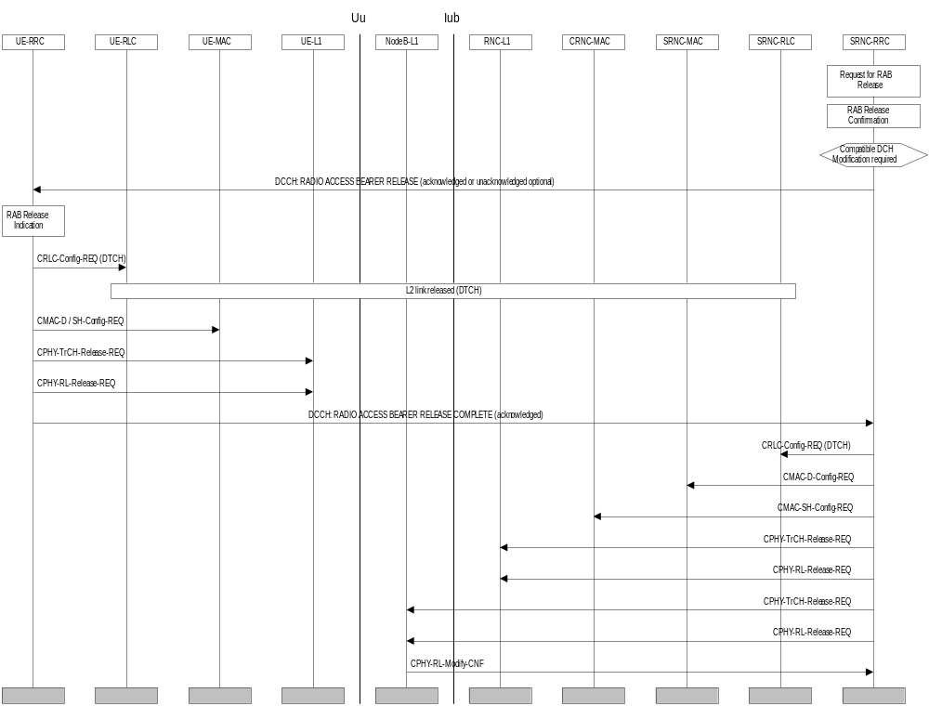
Figure 15: Radio Bearer Release with Unsynchronised Dedicated Physical Channel Modification

Bearer Reconfiguration
For Bearer Reconfiguration, both synchronised and unsynchronised procedures are applicable. The unsynchronised procedure is shown as an example.

Unsynchronised Radio Bearer And Signalling Link ReconfiguraAtion
Because of the unsynchronised nature of the procedure in Figure 16, there is no activation time and no separate commit request for the Node B physical layer is needed. The possibility for executing the requested modification will be reported in the confirmation primitives from the physical layer. If the modification involves the release of an old configuration, the release can be postponed to the end of the procedure. After the reception of a RADIO BEARER AND SIGNALLING LINK RECONFIGURATION REQUEST from the RNC-RRC (acknowledged or unacknowledged transmission optional for the network), the UE executes the modifications on L1 and L2.
Upon reception of a RADIO BEARER AND SIGNALLING LINK RECONFIGURATION COMPLETE message from the UE-RRC, the NW-RRC executes the modifications on L1 and L2. Finally the old configuration, if any, is released from Node B-L1.

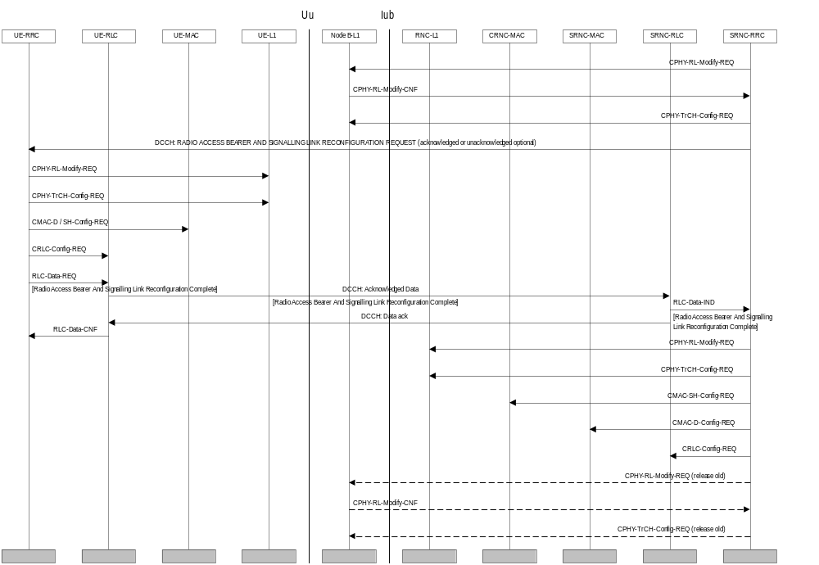
Figure 16: Unsynchronised Radio Bearer Reconfiguration

Transport Channel Reconfiguration
For transport channel reconfiguration, both synchronised and unsynchronised procedures are applicable.

Unsynchronised Transport Format Set Reconfiguration
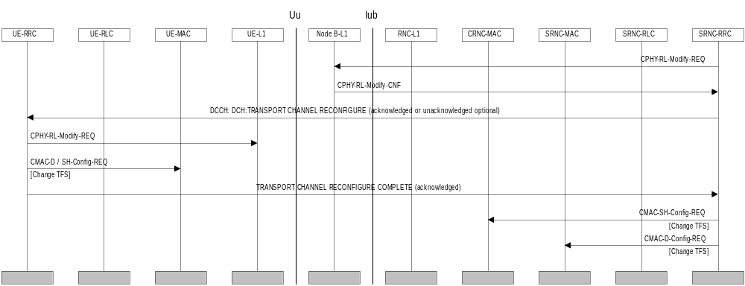
Figure 17: Unsynchronised Transport Format Set Reconfiguration
Figure 17 illustrates an example of a procedure for a change of the Transport Format Set for one transport channel. This is done with the Transport Channel Reconfiguration procedure.
A change of the transport format set for a transport channel is triggered in the RRC layer in the network. A TRANSPORT CHANNEL RECONFIGURE message is sent from the RRC layer in the network to its peer entity (acknowledged or unacknowledged transmission is a network option). This message contains the new transport format set and a new transport format combination Set, i.e. new parameters for L1 and MAC. [Note1: In a synchronised procedure a specific activation time is needed for the change of L1 and L2 configuration to avoid data loss.] When this message is received in the UE a reconfiguration of L1 and MAC is done. A similar reconfiguration is also done on the network side after the reception of a TRANSPORT CHANNEL RECONFIGURE COMPLETE message.
During the reconfiguration of the transport format set for a transport channel, radio traffic on this channel could be halted temporarily since the UE and the network are not necessarily aligned in their configuration. This traffic can resume after the COMPLETE-message.

Asymmetric transport channel reconfiguration
[Note1: This procedure requires new functionality on Iub and is included as FFS, pending confirmation from RAN WG3.]
[Note2: Whether a new procedure is needed, or if the proposal could be incorporated as an enhancement to one of the old procedures is FFS.]
The RNC has initially sent one or more channel configurations (cfg1, cfg2, cfg3...) to each Node B and to the UE, e.g. at RAB Setup.
When a DCH configuration is to be modified, the RNC sends a TRANSPORT CHANNEL RECONFIGURE message to the UE, indicating the new configuration to be applied (e.g. change from cfg3 to cfg2). Each Node B can then configure its physical layer to receive in the new configuration mode at a given radio frame number.
Upon reception of the TRANSPORT CHANNEL RECONFIGURE message, the UE reconfigures uplink L1 and L2 resources and starts to transmit data with the new configuration. In downlink, the UE can switch to the new configuration after a certain time which corresponds basically to the round trip delay. The UE may also avoid any data loss by temporarily performing double decoding.
When a Node B detects the new configuration at the specified radio frame, this is signalled to the RNC over the Iub. If the expected configuration is not detected, then the Node B can revert back to the old configuration. When the RNC detects, from one or more Node Bs, that the new configuration is applied by the UE on the uplink, it starts sending to every Node B, downlink DCH Iub frames with an indication of the new mode to be applied.
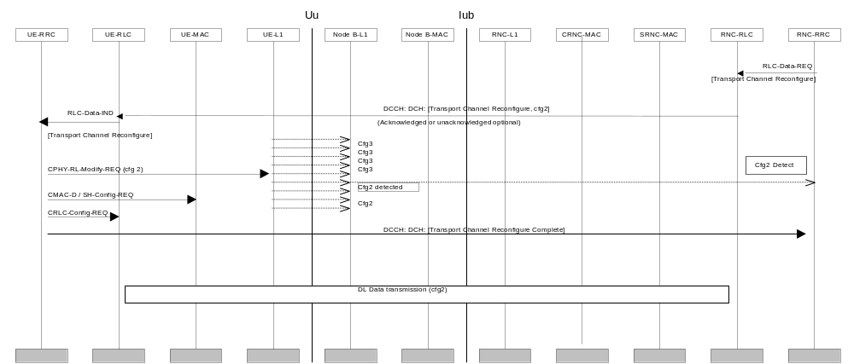
Figure 18: Asymmetric DCH Reconfiguration

Physical Channel Reconfiguration
For physical channel reconfiguration, both synchronised and unsynchronised procedures are applicable.

UE-Originated DCH Activation
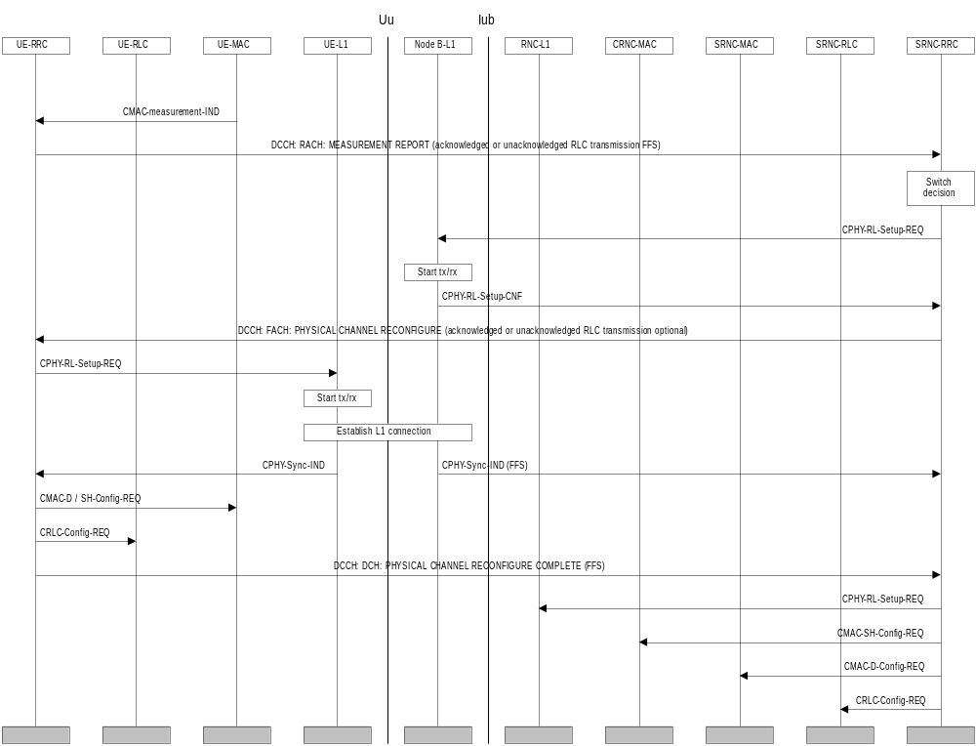
Figure 19: UE-Originated DCH Activation
Figure 19 illustrates an example of a procedure for a switch from common channels (RACH/FACH) to dedicated (DCH) channels.
In the UE the traffic volume measurement function decides to send a MEASUREMENT REPORT message to the network. In the network this measurement report could trigger numerous different actions. For example the network could do a change of transport format set, channel type switching or, if the system traffic is high, no action at all. In this case a switch from RACH/FACH to DCH/DCH is initiated.
Whether the report should be sent with acknowledged or unacknowledged data transfer or if the network should be able to configure data transfer mode for the report is FFS.
First, the modifications on L1 are requested and confirmed on the network side with CPHY-RL-Setup primitives.
The RRC layer on the network side sends a PHYSICAL CHANNEL RECONFIGURE message to its peer entity in the UE (acknowledged or unacknowledged transmission optional to the network). This message is sent on DCCH mapped to FACH. The message includes information about the new physical channel, such as codes and the period of time for which the DCH is activated. [Note1: This message does not include new transport formats. If a change of these is required due to the change of transport channel, this is done with the separate procedure Transport Channel Reconfiguration. This procedure only handles the change of transport channel.]
When the UE has detected synchronisation on the new dedicated channel L2 is configured on the UE side and a PHYSICAL CHANNEL RECONFIGURE COMPLETE message can be sent on DCCH mapped on DCH to RRC in the network (need FFS). Depending on whether the complete-message is applied, the need for an indication of the synchronisation on the NW side is also FFS. Triggered by either the NW CPHY_sync_ind or the L3 complete message, the RNC-L1 and L2 configuration changes are executed in the NW.
When applying the USCH, the “DCCH: RACH: MEASUREMENT REPORT” is replaced by a “DCCH: USCH: DCH REQUEST” message that is transmitted on the USCH in unacknowledged mode. In this case rather than giving a measurement report for the NW to process, the USCH indicates a request for a DCH of predefined capacity.

UE-terminated synchronised DCH Modify
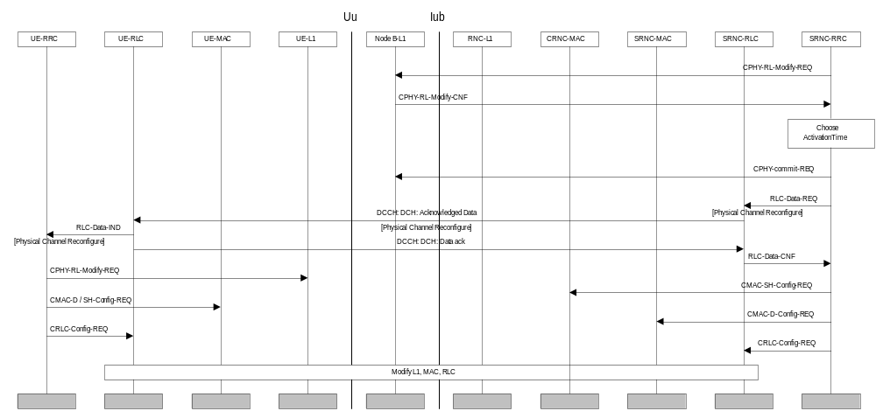
Figure 20: UE-terminated synchronised DCH Modify
Figure 20 illustrates an example of a synchronised procedure for DCH modification. Triggering of this procedure could for example be accomplished by an inactivity timer. The procedure can e.g. release all transport formats of a Radio Bearer without releasing the DCH, due to another bearer using it. The synchronised procedure is applied in the case when the old and new configurations are not compatible e.g. change of channelization code.
After the CPHY-RL-Modify requests have been confirmed, an activation time is chosen by NW-RRC. After deciding upon the activation time, the NW-RRC sends a PHYSICAL CHANNEL RECONFIGURE message as acknowledged data transfer to the UE. In both uplink and downlink this message is sent on DCCH mapped on DCH.
After reception the UE reconfigures L1 and L2 to DCH resources. The need for a Physical Channel Reconfigure Complete message to the network is FFS (not shown here). If a complete message is used it would be sent on DCCH mapped on DCH. In the unsynchronised case this message could trigger a modification of L1 and L2 resources in the network associated with the dedicated channel.

UE-terminated DCH Release
Figure 21 illustrates an example of a procedure for a switch from dedicated (DCH) to common (RACH/FACH) channels. All DCHs used by a UE are released and all dedicated logical channels are transferred to RACH/FACH instead. Triggering of this procedure could for example be an inactivity timer.
A switch from DCH to common channels is decided and a PHYSICAL CHANNEL RECONFIGURE message is sent (acknowledged or unacknowledged data transfer is a network option) from the RRC layer in the network to the UE. This message is sent on DCCH mapped on DCH. [Note1: This message does not include new transport formats. If a change of these is required due to the change of transport channel, this is done with the separate procedure Transport Channel Reconfiguration. This procedure only handles the change of transport channel.]
[Note2: If the loss of L1 sync is used to detect in the NW that the UE has released the DCH:s, as is one possibility in the figure, then there may be a need to configure the Node B-L1 to a short timeout for detecting loss of sync. This is presented by the CPHY_out_of_sync_configure primitives in the figure. The L23 group is seeking guidance from the L1-group relating to the time required for reliable out-of-sync detection. ]
After reception the UE reconfigures L1 and L2 to release old DCH resources. The PHYSICAL CHANNEL RECONFIGURE COMPLETE (need FFS) message to the network is here sent on DCCH mapped on RACH (message acknowledgement on FACH). This message triggers a normal release of L1 and L2 resources in the network associated with the dedicated channel. If the L3 COMPLETE message doesn’t exist, the CPHY_out_of_sync_ind from the physical layer must be applied.
[Note3: When a Switch to RACH/FACH is done it is important to free the old code as fast as possible so that it can be reused. Therefore instead of waiting for the Physical Channel Reconfigure Complete message the network can reconfigure L1 and L2 when the acknowledged data confirmation arrives and the network is sure that the UE has received the Physical Channel Reconfigure message. To be even more certain that the UE has released the old DCH resources the network can wait until after the Out of sync Indication from L1.
These steps including a timer starting when the Physical Channel Reconfigure is sent, gives the network four different indications that the released DCH is really released, and that resources can be reused.]

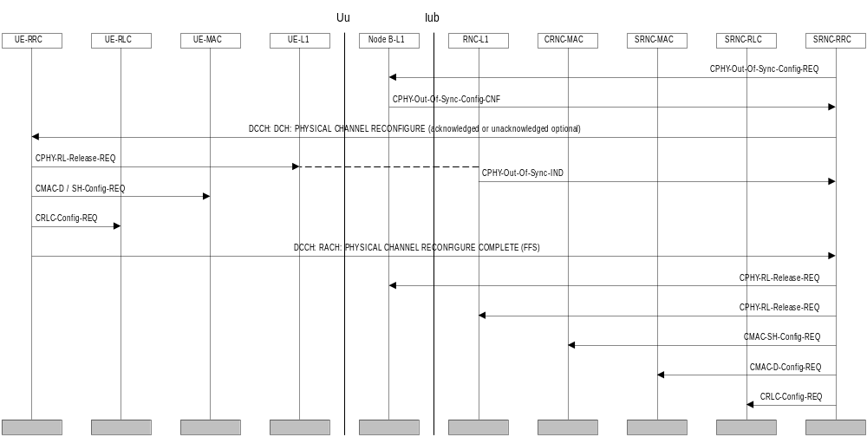
Figure 21: UE-terminated DCH Release

UE-Originated Rapid DCH Initialization
In order to speed up the initialization of the uplink DCH it is necessary to decrease the number of round trips over the Iub link. In order to achieve this the DCCH:FACH:PHYSICAL CHANNEL RECONFIGURE message is piggy-backed on to the CPHY-RL-Setup-REQ instead of waiting for the confirm message – CPHY-RL-Setup-CNF. In addition, since the CPHY-Sync-IND from the RNC L1 to the RNC-RRC will be received prior to the DCCH:DCH:PHYSICAL CHANNEL RECONFIGURE COMPLETE message the latter message is not sent. Instead, as soon as the CPHY-Sync-IND is received at the RNC-RRC, the RNC-L1 and L2 configuration changes are executed in the NW.

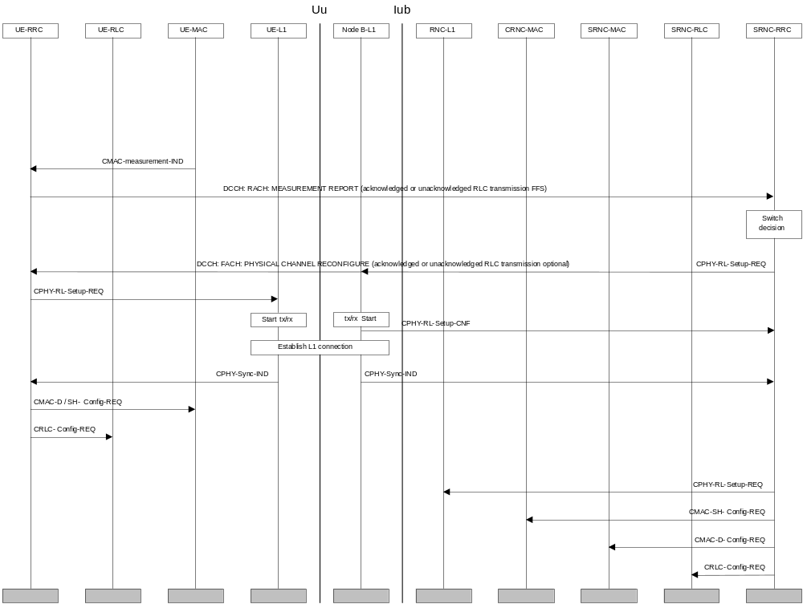
Figure 23 UE-Originated DCH Initialization procedure

Transport Format Combination Control

Transport Format Combination Limitation
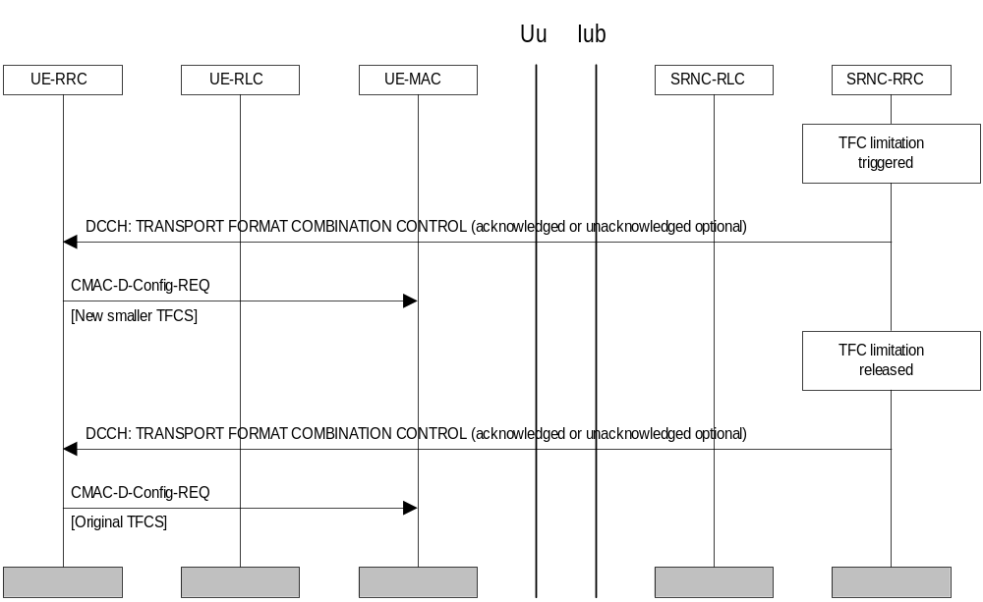
Figure 22: Transport Format Combination Limitation
Figure 22 illustrates an example of a Transport Format Combination Control procedure. A congestion situation occurs and allowed transport format combinations are restricted temporarily. When the congestion is resolved the restriction is removed.
This procedure is initiated with a Transport Format Combination Control message from the network to the UE (acknowledged or unacknowledged transmission optional to the NW). This message contains a subset of the ordinary Transport Format Combination Set. The UE then continues with a reconfiguration of MAC. MAC sees the TFC subset as a completely new set.
Further, after a while when the congestion is resolved a new Transport Format Combination Control message is sent to the UE from the RRC layer in the network. This message contains a subset that is the entire original set. Again, the UE reconfigures the MAC.

Dynamic Resource Allocation Control of Uplink DCH:s
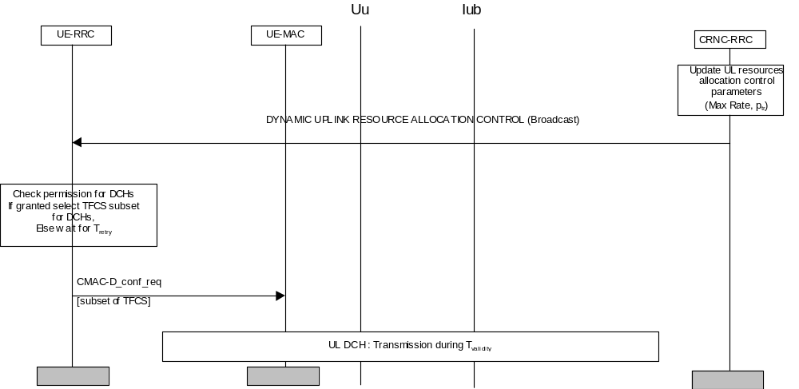
Figure25: Dynamic Resource Allocation Control of Uplink DCHs
Figure 22 illustrates an example of a Dynamic Resource Allocation Control procedure of uplink DCHs. The CRNC regularly broadcasts the following parameters:
- Transmission probability ptr, which indicates the probability for a UE to be allowed to transmit on its DCHs, which are under control by this procedure, during the next period T_{validity}
- Maximum total bit rate allowed to be used by the UE on its DCH which are under controlled by this procedure, during the next allowed period T_{validity}
Besides these parameters, the RNC has allocated the following parameters to the UE:
- Transmission time validity, T_{validity}, which indicates the time duration for which an access for transmission is granted.
- Reaccess time T_{retry}, which indicates the time duration before retrying to access the resources, in case transmission has not been granted.
This procedure is initiated with a Dynamic Uplink Resource Allocation Control message regularly broadcast by the CRNC. It applies to all UEs having DCHs that can be controlled dynamically. The UEs have to listen to this message prior to transmission on these DCHs. The UE RRC checks whether transmission is allowed, and then reconfigures MAC with a new subset of TFCS derived from the maximum total bit rate parameter. This TFCS subset shall control only the DCHs which are under control by this procedure. The UE RRC procedure shall be mandatory for all UEs supporting high bit rate NRT services.
In case of soft handover on the uplink DCH, The UE is requested either to listen to broadcast information from its primary cell (the one with the lowest pathloss), or from all cells involved in its Active Set, depending on its class. In the latter case, the UE is expected to react according to the stricter control information.

Data transmission

Acknowledged-mode data transmission in DCH / DCH + DSCH
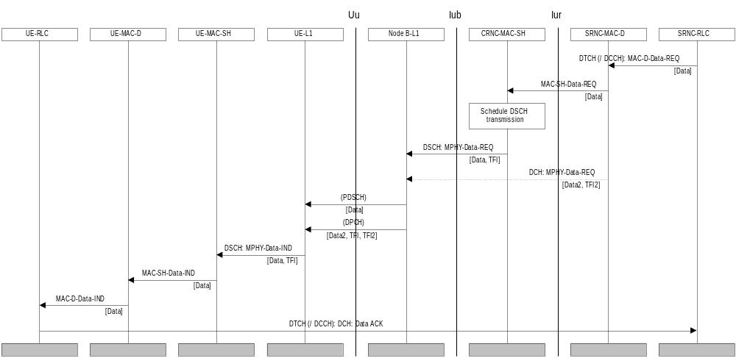
Figure26: Example of acknowledged-mode data transmission on DSCH
RAN WG1 has included into the specification the possibility for not sending the code words corresponding for the DSCH activity from all downlink links (liaison Tdoc RAN WG2 534/99). FFS pending on this reply from RAN WG1 can now be removed from the example on downlink data transmission on the DCH / DCH + DSCH.
Figure26 shows an example of acknowledged-mode data transmission on DSCH in the DCH / DCH + DSCH substate. First RLC in SRNC requests data transmission locally from MAC-d. MAC-d routes the request either locally or across the Iur to MAC-sh in CRNC, where DSCH transmission scheduling takes place. MAC-SH determines the TFI for the data and requests data transmission across Iub from the physical layer in Node B. At the same time data for an associated dedicated channel may arrive in Node B.
TFI for the DSCH and TFI2 for the DCH are combined in the physical layer and transmitted on the DPCCH (dedicated physical control channel) of the associated DPCH (dedicated physical channel). The DSCH data is transmitted separately on the PDSCH (physical downlink shared channel). TFI is used to decode DSCH data, which is then forwarded through MAC-sh and MAC-d to the receiving RLC. An acknowledgement is eventually sent by the UE-RLC mapped to a DCH, unless the DCH is released before the acknowledgement.

Acknowledged-mode data transmission in USCH/FACH
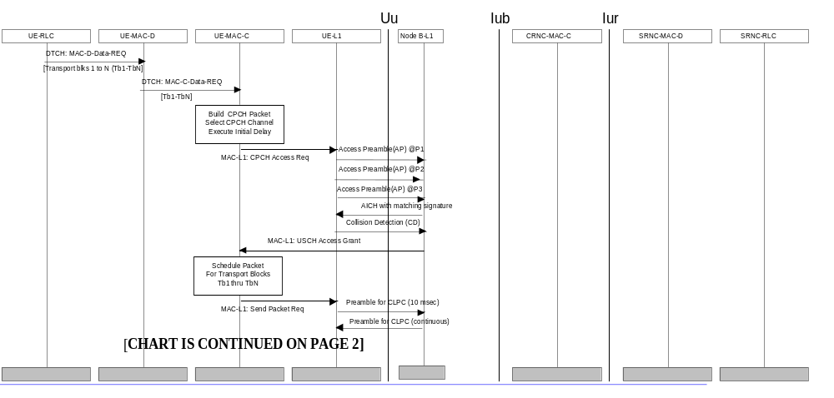Figure27: Example of acknowledged-mode data transmission on RACH+USCH/FACH (page 1 of 2)

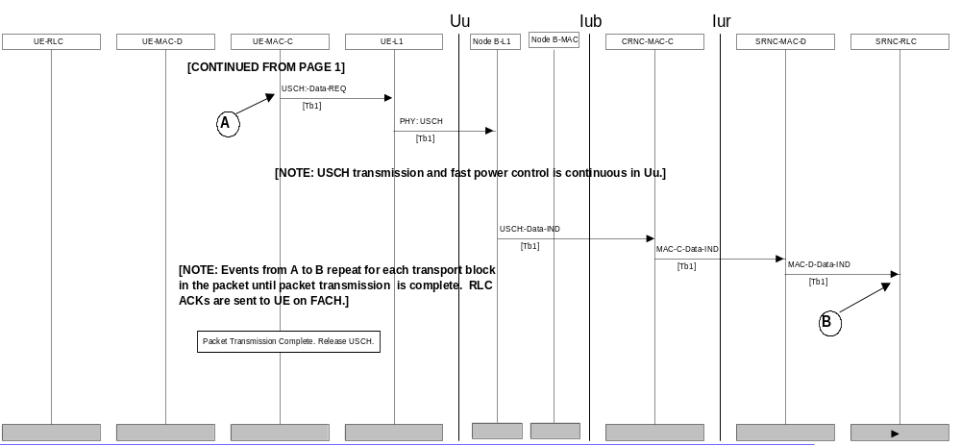Figure28: Example of acknowledged-mode data transmission on RACH+USCH/FACH (page 2 of 2)
Figure 27 and 28 show an example of acknowledged-mode data transmission on USCH while in the RRC Connected state, the RACH+USCH/FACH substate with USCH resources assigned to UE (RACH+USCH/FACH mode). A RAB setup has allocated USCH resources to the logical channel sourcing the data to be transmitted. First RLC in UE requests data transmission locally from MAC-d. MAC-d routes the request to MAC-c, where USCH packet building is done. When the packet size (bytes in PHY for TFI chosen by MAC-c) is known, MAC-c selects one of the available USCH channels from the USCH set it has been assigned to use for this logical channel. Priority access procedure is performed to execute an initial access delay. Then the USCH access procedure is performed between UE and NB to request and obtain the USCH for transmission. The USCH access procedure includes an AP, AICH-ack, CD, and ASSIGN premable messages. When the USCH channel has been assigned, MAC-c schedules the packet for transmission by L1. [NOTE: if the requested channel could not be assigned, MAC-c may select an alternate USCH channel which may have lower capacity. If the lower rate USCH channel were assigned by NB, MAC-c would segment the packet based on the USCH capacity and schedule only the highest priority packet head. The lower priority packet tail would be saved in a MAC queue for later packet transmission.]
After the 10msec period to close the TPC loops on both the USCH UL and CPCCH DL, transport blocks are transmitted, frame by frame, unitl all the packet data is sent. SRNC RLC uses the DCCH to send RLC ACKs to the UE RLC using the FACH DL channel.

Data transfer on USCH/DSCH
In figure 29 a data transfer procedure on USCH/DSCH is presented. It is assumed that the RAB establishment has been performed for example with the RAB Establishment procedure without Dedicated Physical Channel as illustrated in 7.2.1.1.4 and that the RAB is mapped on the USCH and DSCH transport channels.
In the UE the traffic measurement function decides to send a Capacity Request.to the network. In the C-RRC the USCH/DSCH scheduling function will decide to allocate physical resources to this logical channel and RRC in C-RNC sends a PhyShChAllocation to its peer entity in the UE. This message specifies the physical resources and the period of time the MAC-sh can transfer the data on the USCH transport channel.
Both RRC in the CRNC and the UE configure their respective Layer 1 and MAC for the data transfer on the USCH and at the specified time MAC-sh in the UE convey the data using the specified PUSCH resources.
This operation may be repeated several times till the RLC buffer is empty.
In the diagram it is assumed that the PhyShChAllocation has allocated additionally to the PUSCH resources some PDSCH resources, so that at the time specified in the allocation message both RRC in the CRNC and the UE configure their respective Layer 1 and MAC for the data transfer on the DSCH and at the specified time MAC-sh in the UE convey the acknowledgement message of the RAN RLC to its UE peer entity using the specified PDSCH resources.

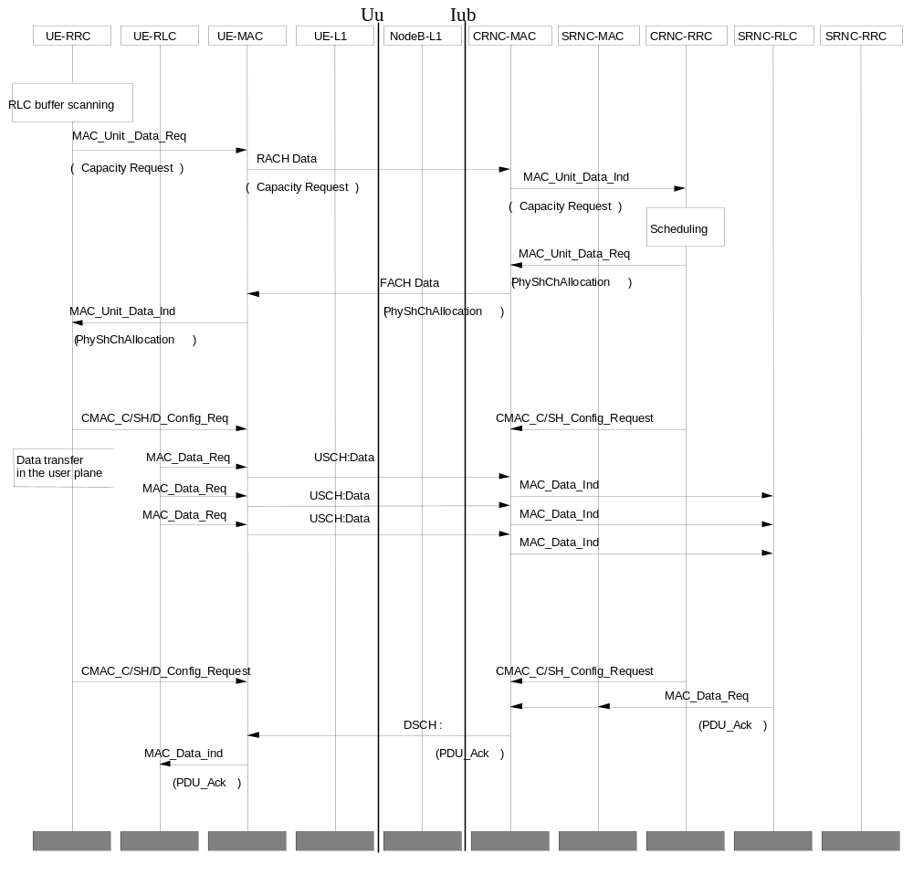

Figure 29 Data transfer on USCH/DSCH

RRC Connection mobility procedures
The RRC handover protocol must be common for the FDD and TDD modes. This means that the same protocol must support all the following handover procedures

Handover Measurement Reporting
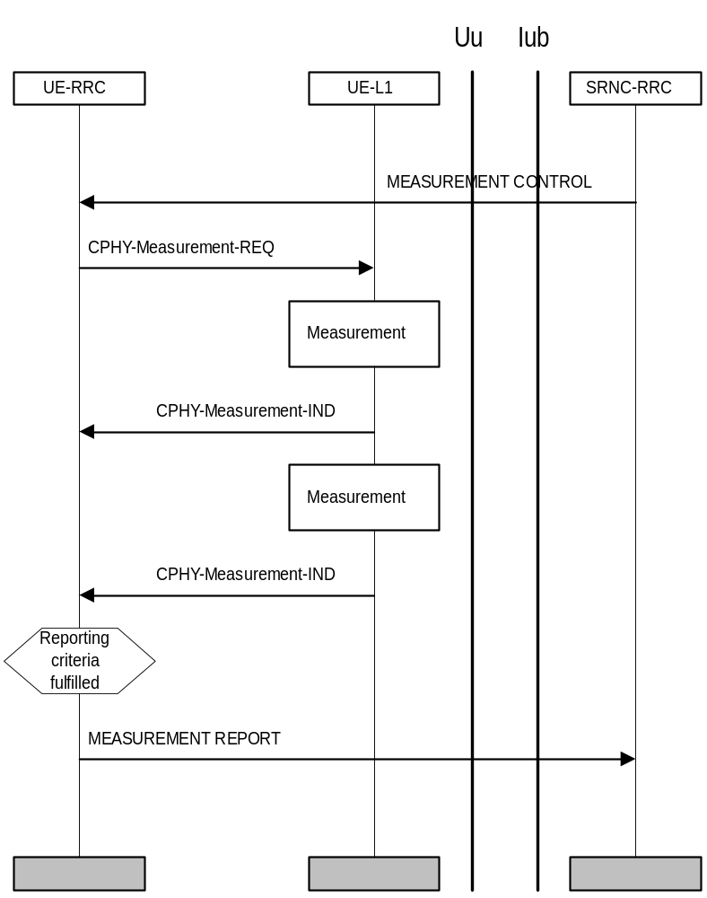
Figure30: Handover measurement reporting
Figure illustrates an example where a measurement control and a measurement report procedure is used for handover measurements. The NW RRC requests the UE to start measurements and reporting with a MEASUREMENT CONTROL message. The message includes an indication of a measurement type (e.g. intra-frequency measurement), the radio links to evaluate, the reporting criteria and a measurement identity number. The UE configures L1 to start measurements. When measurement reporting criteria are fulfilled the UE sends a MEASUREMENT REPORT message.

Cell Update
[Note: This example currently applies only in the case of RRA change.]
Figure 23 illustrates an example of a cell update procedure. The signalling is performed on the CCCH using transparent data transfer.
The cell update procedure is a forward handover procedure. It is triggered by the cell re-selection function in the UE, which notifies which cell the UE should switch to. The UE reads the broadcast information of the new cell. Subsequently, the UE RRC layer sends a CELL UPDATE REQUEST message to the RAN RRC via the MAC SAP for the CCCH logical channel and the RACH transport channel. The RACH transmission includes the current RNTI.
[Editor’s Note: The logical channel to be used and the routing of the message are FFS, thus Figure 23 only illustrates one possible approach.]
Upon reception of the CELL UPDATE REQUEST, the RAN registers the change of cell and replies with a CELL UPDATE CONFIRM message transmitted on the CCCH/FACH to the UE. The message includes the current RNTI and may also include a new RNTI.
If the registration fails, a Cell Update Reject (not shown in the figure) is transferred on CCCH and message routing across Iur is similar to the CELL UPDATE message.

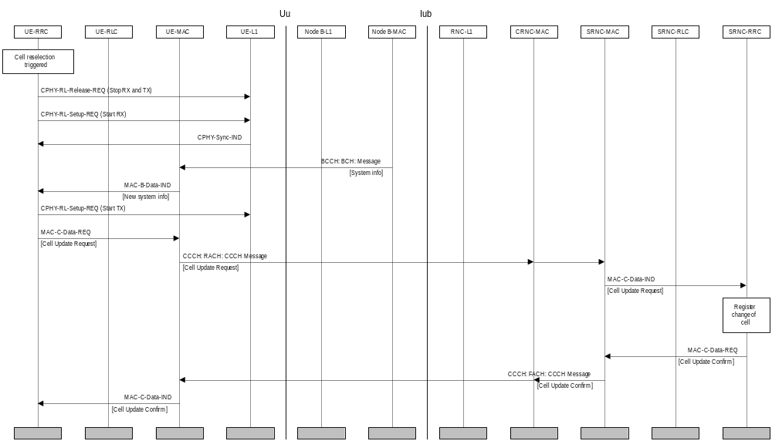
Figure 23: Cell update procedure

RRA Update
Figure 24 illustrates an example of a RRA Update procedure. The signalling is performed on the CCCH.
When cell re-selection is triggered, the UE abandons the radio link in the old cell and establishes a radio link to the new cell. The RRA update procedure is triggered when the UE reads the broadcast information of the new cell and recognises that a RRA update is required. After that, the UE RRC layer sends a RRA UPDATE REQUEST on the CCCH to the UE MAC layer, which transfers the message on the RACH to RAN. The RACH transmission includes the current RNTI.
[Editor’s Note: The logical channel to be used and the routing of the message are FFS, thus Figure 24 only illustrates one possible approach.]
Upon reception of the RRA UPDATE REQUEST, the RAN registers the change of RRA. Then the RAN RRC layer requests the RAN MAC layer to send a RRA UPDATE CONFIRM message on the FACH to the UE. The message includes the current RNTI and may also include a new RNTI.
The logical channel used for RRA UPDATE CONFIRM depends on the SRNC relocation policy. If SRNC is always relocated before RRA UPDATE CONFIRM is sent, a DCCH should be used (to allow ciphering of the message contents). If SRNC is not relocated, the CCCH logical channel should be used to be able to utilize the RNSAP Iur procedures and not being forced to set up user plane on the Iur for this procedure.
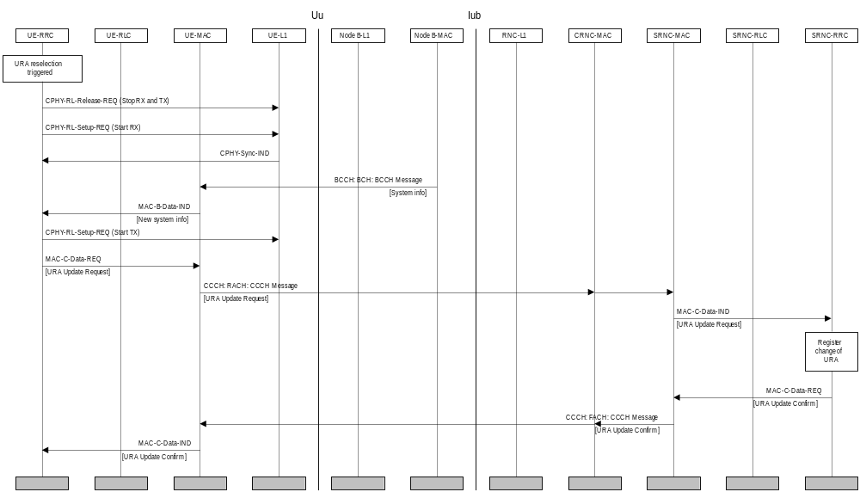
Figure 24: RRA update procedure

Radio Link Addition

The NW RRC determines the need for radio link addition based on received measurement reports or load control algorithms. When radio links are to be added, the NW RRC first configures the NW L1 to activate the radio link(s) that are being added.
Radio link addiation procedure is similar to Figure 33.

Radio Link Removal

The NW RRC determines the need for radio link removal based on received measurement reports or load control algorithms. When radio links are to be replaced, the NW RRC first configures the NW L1 to activate the radio link(s) that are being removed.
Radio link removal procedure is similar to Figure 33.

Combined radio link addition and removal
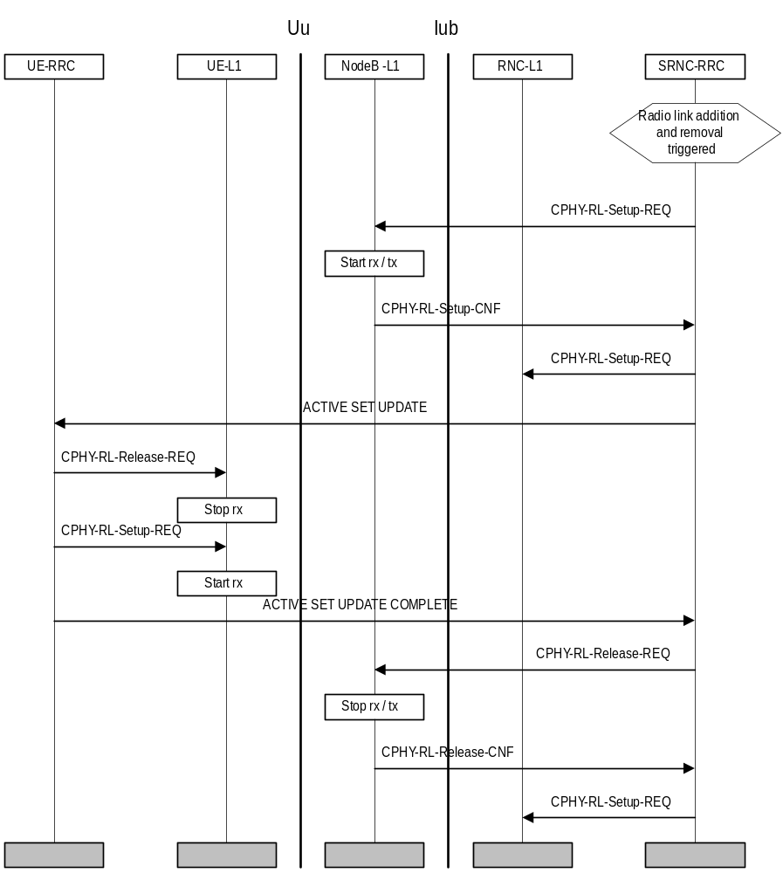
Figure 25: Combined Radio Link Addition And Removal
Figure 25 illustrates a combined radio link addition and removal procedure. The NW RRC determines the need for radio link replacement based on received measurement reports or load control algorithms.
When radio links are to be replaced, the NW RRC first configures the NW L1 to activate the radio link(s) that are being added. The NW RRC then sends an ACTIVE SET UPDATE message to the UE RRC, which configures the UE L1 to terminate reception on the removed radio link(s) and begin reception on the added radio link(s).
If the UE active set is full, the replacement has to be performed in the order defined in Figure 25. If UE has only one radio link, then the replacement must be done in reverse order (first add, then remove). Note: The present assumption is that the order of the replacement can be left to the UE.
The UE RRC acknowledges the replacement with an ACTIVE SET UPDATE COMPLETE message. The NW RRC then configures the NW L1 to terminate reception and transmission on the removed radio link.

Hard Handover
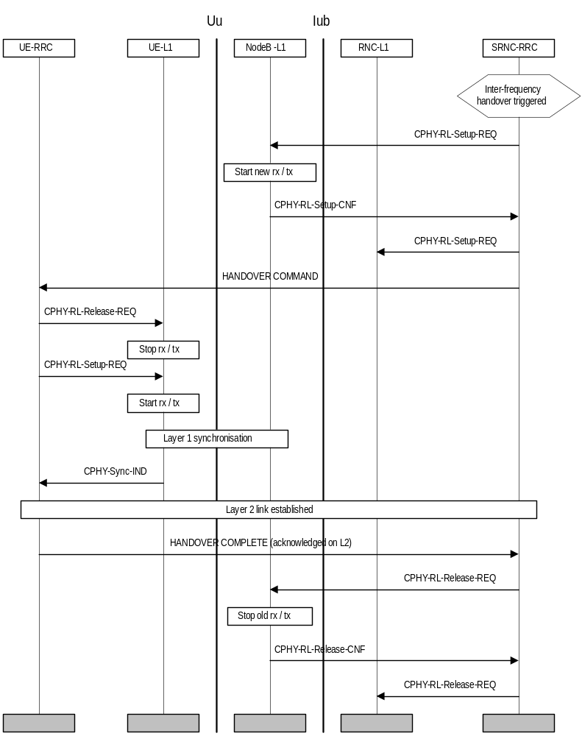
Figure34: Hard handover
Figure illustrates a hard handover. The NW RRC determines the need for hard handover based on received measurement reports or load control algorithms.
For inter-frequency handover the measurements are assumed to be performed in slotted mode.
The NW RRC first configures the NW L1 to activate the new radio links. The NW L1 begins transmission and reception on the new links immediately. The NW RRC then sends the UE RRC a HANDOVER COMMAND message. The message indicates the radio resources that should be used for the new radio link. The UE RRC configures the UE L1 to terminate reception on the old radio link and begin reception on the new radio link.
After the UE L1 has achieved downlink synchronisation on the new frequency, a L2 link is established and the UE RRC sends a HANDOVER COMPLETE message to the NW RRC. After having received the L3 acknowledgement, the NW RRC configures the NW L1 to terminate reception and transmission on the old radio link.
[Note 1: Whether it should be possible to setup several radio links immediately on the new frequency is FFS.]
[Note 2: The suspension and resuming of the CC and MM signalling during handover is FFS.]

RRC Connection re-establishment
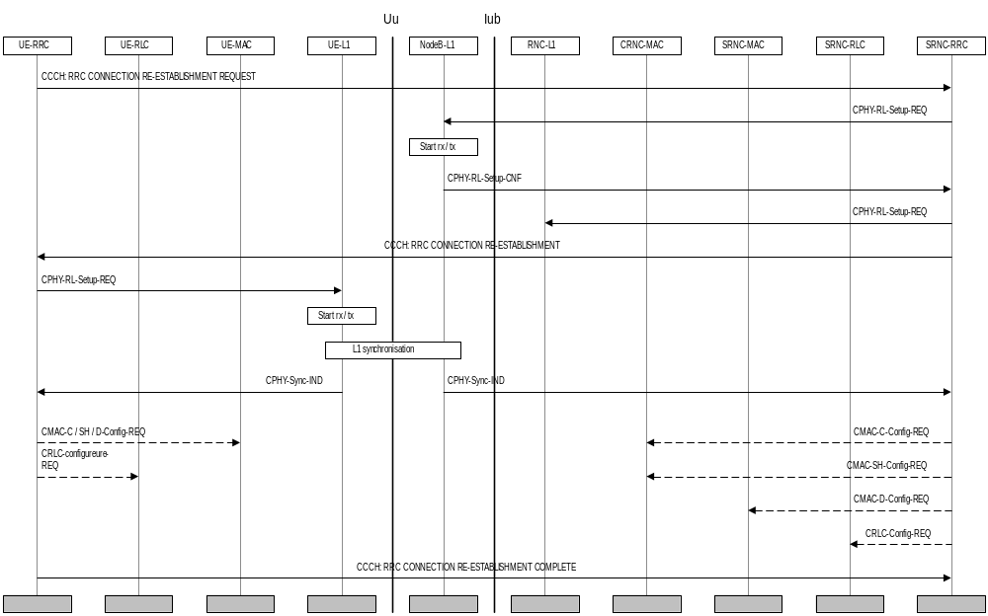
Figure 26: RRC connection re-establishment
Figure 26 shows an example of an RRC connection re-establishment procedure. RRC connection re-establishment is needed, when a UE loses radio connection due to e.g. radio link failure. After having selected a new cell, the UE RRC sends the NW RRC an RRC CONNECTION RE-ESTABLISHMENT REQUEST message. The NW RRC configures the NW and acknowledges the connection re-establishment to the UE RRC with an RRC CONNECTION RE-ESTABLISHMENT message. The UE RRC configures the UE L1 to activate the new radio link(s). After the UE has synchronised to at least one radio link, the MAC and RLC layers can be configured (if necessary).
When the procedure is completed on the UE side, an RRC CONNECTION RE-ESTABLISHMENT COMPLETE message is sent.

Inter-system Handover: GSM/BSS to TD-SCDMA RAN
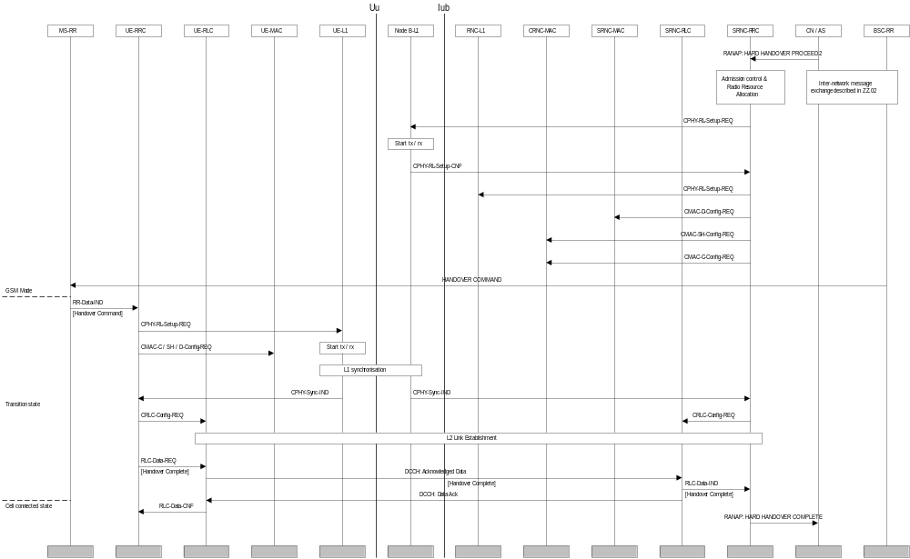
Figure 27: GSM to TD-SCDMA inter-system handover
The handover from GSM/BSS to TD-SCDMA RAN for a dual-mode GSM MS / TD-SCDMA UE is illustrated in Figure 27. On the network side, upon the reception of a HARD HANDOVER PROCEED 2 command through the RANAP protocol, the RRC layer performs admission control and radio resource allocation assigning an RNTI for the RRC connection and selecting radio resource parameters (such as transport channel type, transport format sets, etc). RRC configures these parameters on layer 1 and layer 2 to locally establish the DCH logical channel.
The selected parameters including the RNTI, were previously transmitted to UE via RANAP message HARD HANDOVER PROCEED 1 and GSM upgraded message HANDOVER COMMAND.
Upon reception of the HANDOVER COMMAND message, the GSM RR layer transmits the required parameters to the TD-SCDMA RRC layer using an RR-Data-IND primitive. UE RRC configures L1 and L2 using these parameters to locally establish the DCH logical channel. Layer 1 indicates to RRC when it has reached synchronisation. An RLC signalling link establishment is then initiated by the UE. A HANDOVER COMPLETE message is finally sent by the UE.

Inter-System Handover: TD-SCDMA RAN to GSM/BSS, PSTN/ISDN domain services
[Note: The scope of this description is restricted to a UE having a connection only to PSTN/ISDN services, i.e. no simultaneous IP connection]
For PSTN/ISDN domain services RAN Inter-System Handover procedure is based on measurement reports from the UE but initiated from the RAN. INTER-SYSTEM HANDOVER COMMAND is sent using acknowledged data transfer on the DCCH. The UE transition from RAN Connected Mode starts when an INTER-SYSTEM HANDOVER COMMAND is received. The transition to GSM Connected mode is finished when HANDOVER COMPLETE message is sent from the UE.

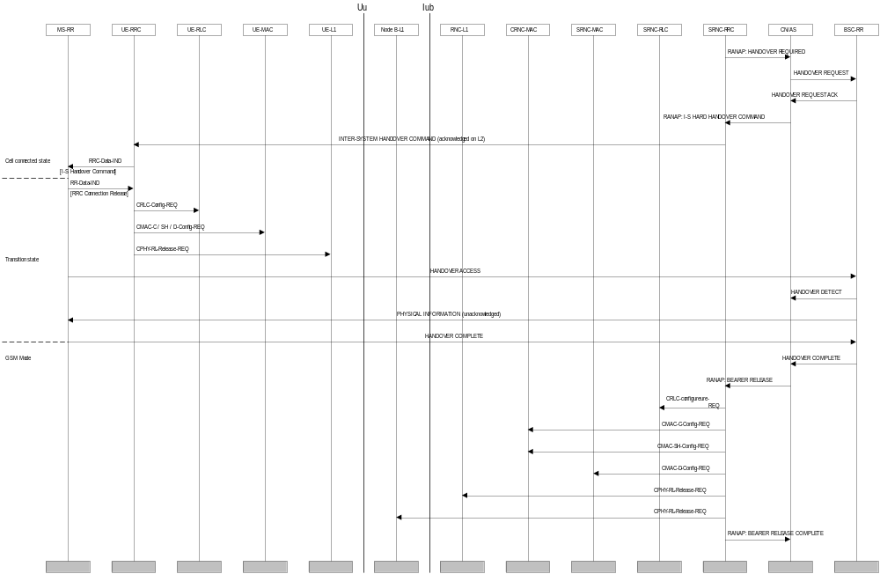
Figure 28: TD-SCDMA to GSM inter-system handover
RAN sends a HANDOVER REQUIRED to CN/AS. This message contains information needed for the GSM system to be able to perform a handover (e.g. serving cell, target cell). Some parts of this information (e.g. MS classmark) have been obtained at call setup of the RAN Connection and are stored in CN.
The CN/AS sends a HANDOVER REQUEST message to BSC-RR allocating the necessary resources to be able to receive the GSM MS and acknowledge this by sending HANDOVER REQUEST ACKNOWLEDGE to CN/AS. The HANDOVER REQUEST ACKNOWLEDGE contains all radio-related information that the UE needs for the handover.
CN/AS sends a INTER-SYSTEM HANDOVER COMMAND (type RAN-to-BSS HARD HANDOVER) to the UE to start the execution of the handover. This message contains all the information needed for the UE to be able to switch to the GSM cell and perform a GSM handover.
Upon reception of the HANDOVER COMMAND message, TD-SCDMA RRC forwards the handover mparameters to the GSM RR layer using an RRC-Data-IND primitive. To release the resources from TD-SCDMA the RR layer transmits to the TD-SCDMA RRC an RRC Connection Release message using an RR-Data-IND primitive. The RRC layer can then locally release the resources on the RLC, MAC and physical layers of the UE.
After having switched to the assigned GSM channel received in the INTER-SYSTEM HANDOVER COMMAND, the GSM MS sends HANDOVER ACCESS in successive layer 1 frames, just as it typically would have done for a conventional GSM handover initiation.
When the BSC-RR has received the HANDOVER ACCESS it indicates this to the CN/AS by sending a HANDOVER DETECT message. The BSC-RR sends a PHYSICAL INFORMATION message to the GSM MS in unacknowledged mode that contains various fields of physical layer -related information allowing a proper transmission by the MS.
After layer 1 and 2 connections are successfully established, the GSM MS returns the HANDOVER COMPLETE message.
CN/AS is then able to release the RAN resources that were used for the UE in RAN Connected Mode. The CN/AS send a BEARER RELEASE command to RAN, after which RAN can release all NW resources from RLC, MAC and the physical layer. When the release operation is complete, a BEARER RELEASE COMPLETE message is sent to CN / AS.

Baton handover

Baton handover procedure is based on the position information (include UE-BS distance, UE speed and direction, ect. ) of all active UEs, which is obtained by smart antenna and uplink synchronization technology, but initiated from the RAN. A BATON HANDOVER COMMAND message is sent using acknowledged data transfer on the DCCH. The UE transition from RAN Connected Mode starts when a BATON HANDOVER COMMAND is received.

CN originated paging request in connected mode

RAN coordinated paging using DCCH
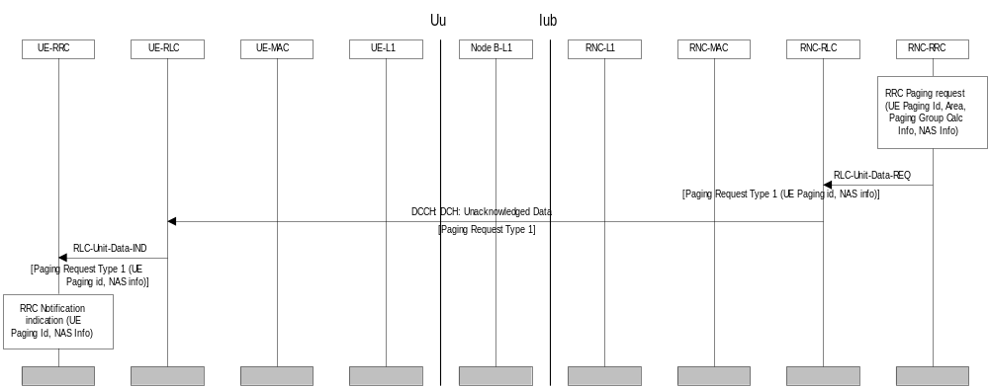
Figure 29. Example sequence of CN initiated paging request using DCCH
The above sequence illustrates a CN originated paging request, when the UE is in connected mode and can be reached on the DCCH. The coordination of the paging request with the existing RRC connection is done in RAN.
The entity above RRC on the network side requests paging of a UE over the Nt-SAP. The request contains a UE paging identity, an area where the page request is to be broadcast, information for calculation of the paging group and NAS information to be transparently transmitted to the UE by the paging request.
Since the UE can be reached on the DCCH, the RRC layer formats a Paging Request Type 2 message containing the UE paging identity and the NAS information, and the message is transmitted directly to the UE using unacknowledged data transfer.

RAN coordinated paging using PCCH

The RRC layer in the RAN can use this procedure to trigger a switch from PCH or RRA connected state to RACH/FACH or RACH+USCH/FACH state. A paging message (Maybe a Paging Request Type 1 message ) containing the S-RNTI and SRNC identity is sent on the PCCH.
In the UE, the RRC layer continuously monitors the paging group on the PCCH and compares the UE identities in the received paging messages with its own identities. When a match occurs, the RRC layer uses the cell update procedure to acknowledge the reception of paging and optionally obtain a new C-RNTI.

UE coordinated paging
FFS.

RAN originated paging request and paging response

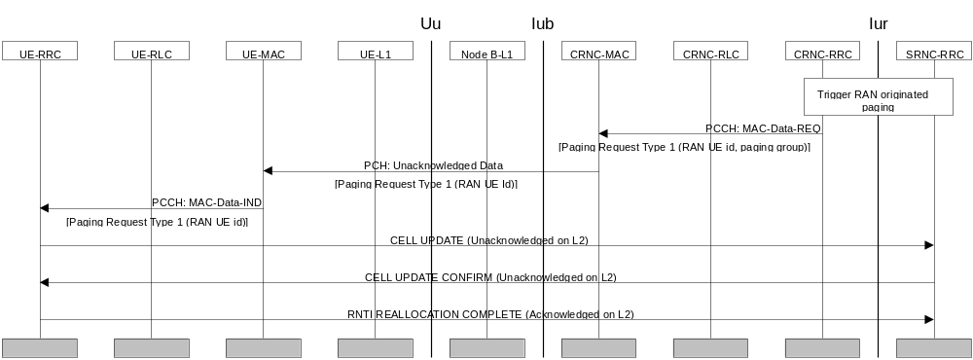
Figure 30. Example sequence for RAN initiated paging request with paging response

The RRC layer in the network uses this sequence to trigger a switch to RACH/FACH substate of the cell connected state, when the UE can only be reached on the PCH (the PCH substate of cell connected state or the RRA connected state). A Paging Type 1 message is prepared, containing the RAN UE identity (s-RNTI + RNC-ID). The RRC requests the transmission of the message by MAC on the PCCH, indicating the paging group.
In the UE, the RRC layer continuously monitors the paging group on the PCH and compares the UE identities in received paging request messages with its own identities. A match occurs, and in this case the RRC layer changes state to RACH/FACH substate within the cell connected mode.
The UE prepares a Cell Update message, which is sent on CCCH or DCCH (ffs).
[Note: The content of the Paging Response Type 2 message is FFS. It could e.g. be measurements.]
When the network receives the Cell Update message, a c-RNTI is allocated and signalled to UE using the Cell Update Confirm message, which is sent on CCCH or DCCH (ffs) using unacknowledged mode. The latter message also acknowledges the reception of the Cell Update message. The UE configures MAC to use the new c-RNTI and prepares a RNTI Reallocation Complete message. When the network receives the RNTI Reallocation Complete message on DCCH it can delete any old c-RNTI and the DCCH/DTCH logical channels can be used also in the downlink using the new c-RNTI.

Other procedures

UE Capability Information
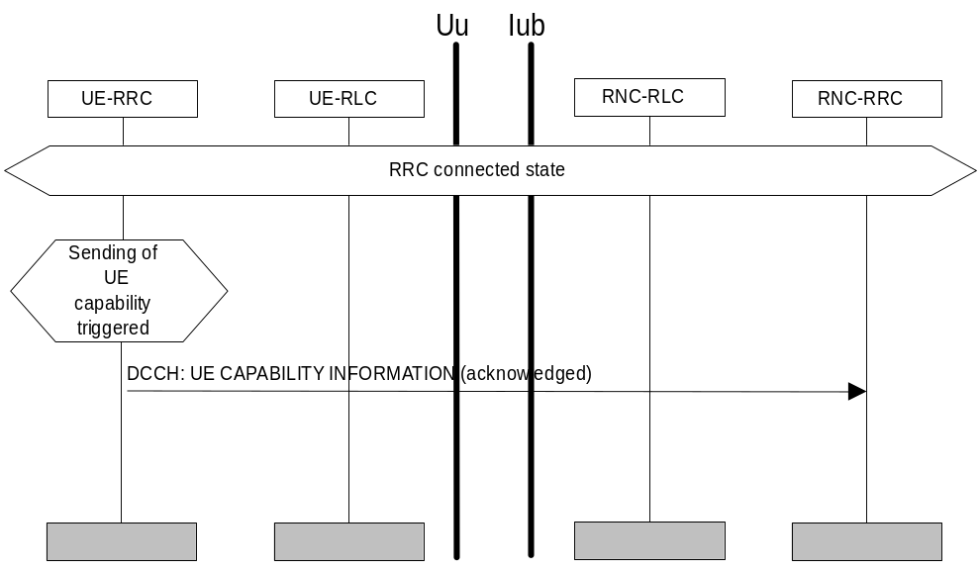
Figure 40. UE Capability Information
The UE transfers its capability information to the network by transmitting the RRC message UE Capability Information using acknowledged mode on the DCCH. This procedure can (optionally) be performed after RRC Connection Setup procedure and also during the lifetime of the RRC Connection if the UE capability information changes (e.g. due to change in UE power class). UE capability information can also explicitly be requested by RAN.

7.7.2 Random access transmission sequence
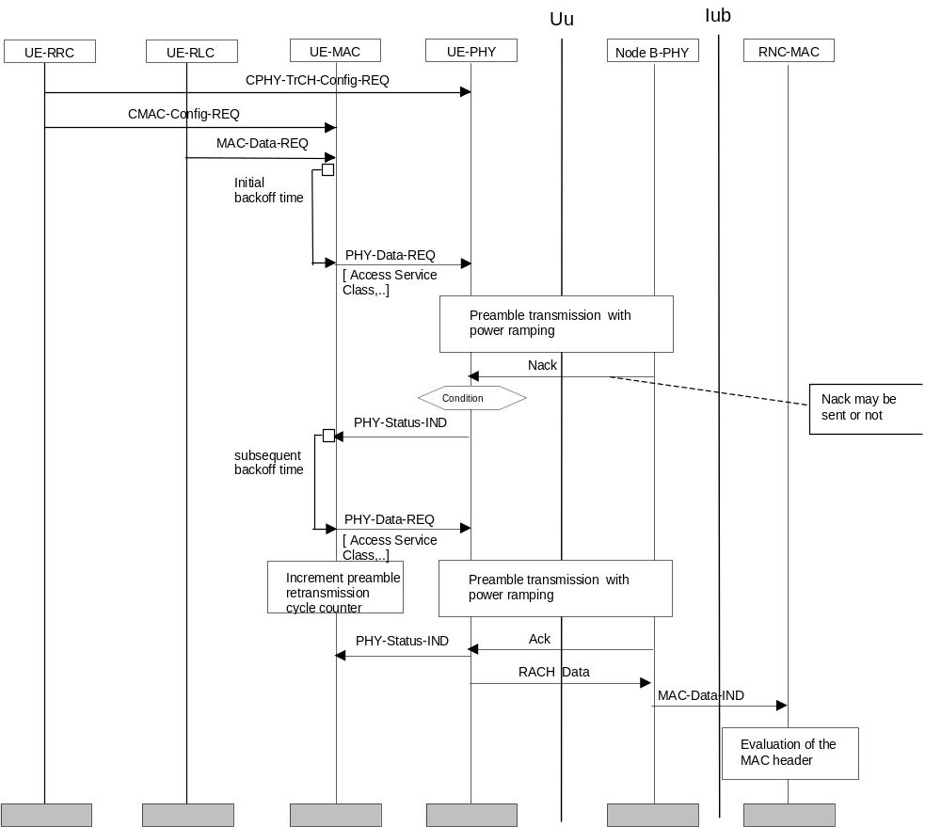
Figure 41 Random access transmission sequence procedure

The RACH is configured once via a CPHY-TrCH-Config-REQ primitive. This primitive is issued only for initial configuration or when a parameter shall be changed, not for every RACH transmission.
The CMAC-Config-REQ primitive is used to configure MAC parameters required for the random access procedure (e.g. persistence value, maximum number of preamble ramping cycles, initial and subsequent backoff times).
When there is data to be transmitted on the RACH, i.e. reception of a MAC-Data-REQ primitive, the RACH transmission control procedure is started.
After some initial backoff, a primitive PHY-Data-REQ is sent to L1. This triggers the PRACH preamble transmission procedure, i.e. the physical layer selects a PRACH access slot and signature without further backoff delay imposed on L1.
If the maximum permitted transmission power was reached without receiving an acknowledgement, or a negative acknowledgement (Nack) has been received, the preamble ramping cycle is repeated. The number of preamble ramping cycles is counted in MAC.
Upon successful transmission of a preamble, MAC receives an acknowledgement via PHY-Status-IND primitive that the acquisition indicator was received and the message sent.

Traffic volume monitoring

Figure 42 illustrates the example of message sequence of traffic volume monitoring procedure. RRC in UE gets the parameters necessary for traffic volume measurement from Measurement Control message or System information message sent by RRC in RAN. RRC in UE passes the MAC the parameters for traffic volume measurement with the CMAC-Measurement-REQ. Meanwhile, RLC passes the data to MAC with buffer status. There are two ways MAC indicates the traffic volume measurement report to RRC, periodic and event-triggered. If it is periodic report, the MAC reports the measurement result to RRC periodically. If it is event-triggered, MAC in UE reports the measurement result to RRC when the result is beyond the speficied threshold value. After that, based on the measurement report from MAC and reporting criteria received from RAN, RRC makes a decision whether it should send Measurement Report Message to RAN. When RRC in RAN receives the Measurement Report Message, it takes a proper action based on the measurement report from UE. It can be bearer reconfiguration, transport channel reconfiguration, physical channel reconfiguration or transport channel combination control procedure. The report mode, periodic and event-triggered, can be used exclusively, or simultaneously as shown in figure 42.

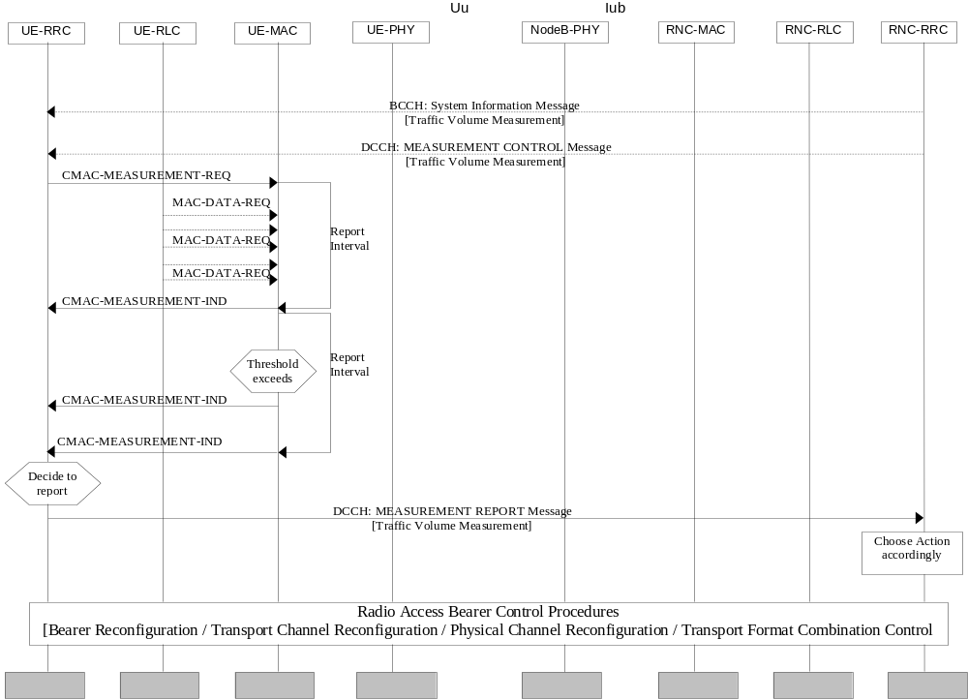
Fig 42 Traffic Volume Measurement Report Procedure

Annex A (informative): RRC Connection Establishment - Case C
This protocol termination case has been excluded from the initial TD-SCDMA release, thus the procedure is captured here for information.
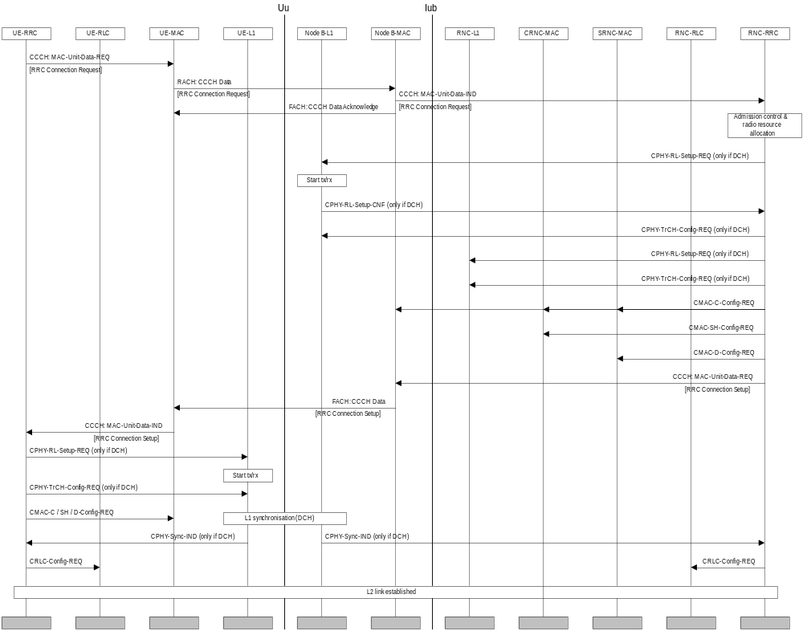
Figure 43 RRC connection establishment with common channel termination case C
The difference between case A and case C common channel termination points is that in case C RACH and FACH transport channels are terminated in Node B. An Access Acknowledgement message is sent from Node B to the UE to acknowledge the reception of the Access request. Similarily, the Access Grant message from the network is transmitted via the Node-B MAC.

History
Document history
Date | Version | Comment
July, 1999 | 1.0 | Document created based on the documents 3GPP 25.303 “UE Functions and Interlayer Procedures in Connected Mode”,v.3.0.1
Aug.5, 1999 | 1.1.0 | Based on CWTS WG1 Ad Hoc1 #2 meeting in CQUPT
Aug.29, 1999 | 2.0.0 | Based on CWTS WG1 Ad Hoc1 #3 meeting in Beijing
Oct.14, 1999 | 3.0.0 | Document accpted by CWTS WG1 Ad Hoc1 #4 and CWTS WG1#5 in Beijing
Editor for CWTS TS C003, UE functions and interlayer procedures in connected mode, is
Mr. XIE Xianzhong
CATT
Email: xiexzh@pub.tdscdma.com
This document is written in Microsoft word 97.

This document is written in Microsoft word 97.

